**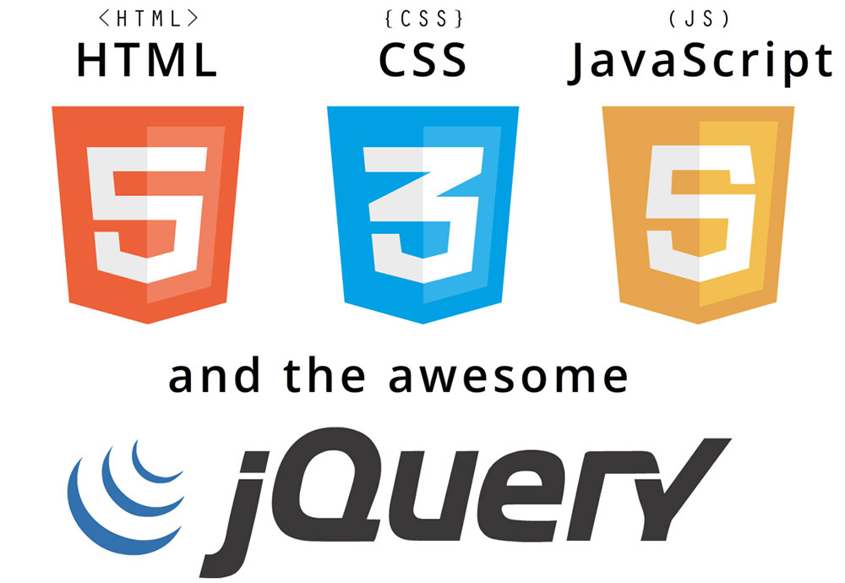**

|  |
| --- |
| Complete website tutorial  Author: Rob Sims |

|  |  |  |
| --- | --- | --- |
| Responsive design |  |  |
| HTML5  CSS3 | JavaScript  jQuery |  |

TABLE OF CONTENTS

[Change log 4](#_Toc509225934)

[Introduction 5](#_Toc509225935)

[Notes 5](#_Toc509225936)

[Part 1 6](#_Toc509225937)

[Structure of the HTML5 website 6](#_Toc509225938)

[Design 6](#_Toc509225939)

[Let’s start coding 7](#_Toc509225940)

[Creating the site in DreamWeaver 8](#_Toc509225941)

[Creating index.html page 10](#_Toc509225942)

[Creating the head – CSS files 12](#_Toc509225943)

[Creating the head – JavaScript / jQuery files 15](#_Toc509225944)

[Creating the body – Introduction 21](#_Toc509225945)

[Creating the body – Building the website structure 22](#_Toc509225946)

[Part 2 36](#_Toc509225947)

[Creating the styling – Defining the global rules 36](#_Toc509225948)

[Creating the styling – Defining the section rules 40](#_Toc509225949)

[Creating the styling – Making it responsive 64](#_Toc509225950)

[Part 3 72](#_Toc509225951)

[Creating interactivity – JavaScript and jQuery 72](#_Toc509225952)

[Creating the JavaScript – Coding the slider content 72](#_Toc509225953)

[Creating the JavaScript – Coding the mobile menu 75](#_Toc509225954)

[Part 5 88](#_Toc509225955)

[Adding a contact form 88](#_Toc509225956)

[Building the HTML Form 88](#_Toc509225957)

[Submitting the Form Using AJAX 97](#_Toc509225958)

[Creating the PHP Mailer Script 102](#_Toc509225959)

[Appendices 106](#_Toc509225960)

[Appendix A 106](#_Toc509225961)

[Appendix B 106](#_Toc509225962)

[ 106](#_Toc509225963)

# Change log

|  |  |  |  |
| --- | --- | --- | --- |
| Version | Date | Change | Author |
| 0.1 | 9/3/2018 | Initial Draft | Rob Sims |
| 1.0 | 13/3/2018 | Tutorial complete | Rob Sims |
| 1.1 | 14/3/2018 | Added part 5 – AJAX contact form | Rob Sims |
| 1.2 | 17/3/2018 | Refined Contact form section (kept styling of HTML tags consistent) and clarified some instructions as a result of student feedback. | Rob Sims |
| 1.3 | 19/3/2015 | Add appendices for uploading to college server and using XAMPP | Rob Sims |

# Introduction

In this responsive web design tutorial, we will create an awesome responsive HTML5 website starting from scratch. I tried to include as many different features as possible, so we will be dealing with a jQuery slider, CSS3 transitions and animations, CSS Media Queries and so on. The first part of the tutorial will show you the HTML structure and the required scripts in a step by step tutorial. The second part will then show you how to style it using CSS3 features to create this stunning HTML5 responsive website.

## Notes

Please note that this tutorial is made for people who already have an basic knowledge level and are familiar with the DreamWeaver application. Some parts of the tutorial will not be described in detail as it is assumed that you know how to e.g. include a CSS file. If you have any questions please ask your tutor.

# Part 1

## Structure of the HTML5 website

For the purposes of this tutorial, we’ll be aiming to build a fully responsive website. But what do we mean by responsive? Responsive Web Design makes your web page look good on all devices (desktops, tablets, and phones).

Responsive Web Design is about using HTML and CSS to resize, hide, shrink, enlarge, or move the content to make it look good on any screen.

### Design

First of all, let´s have a look at the basic structure of our website. The image below shows how our website will be arranged.

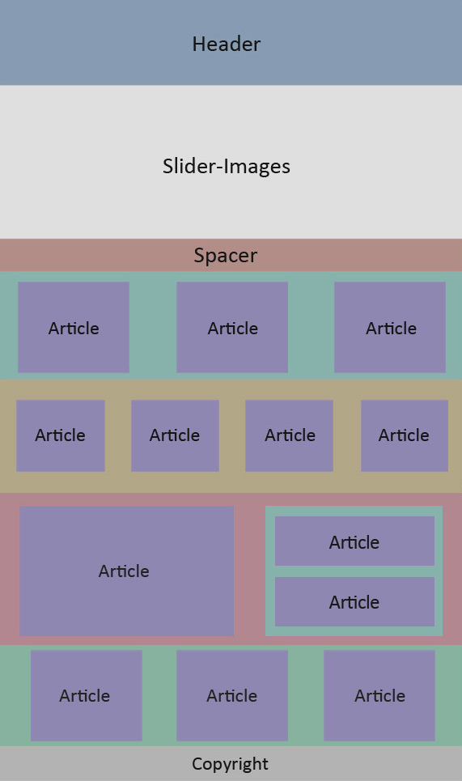

Figure 1 Website layout

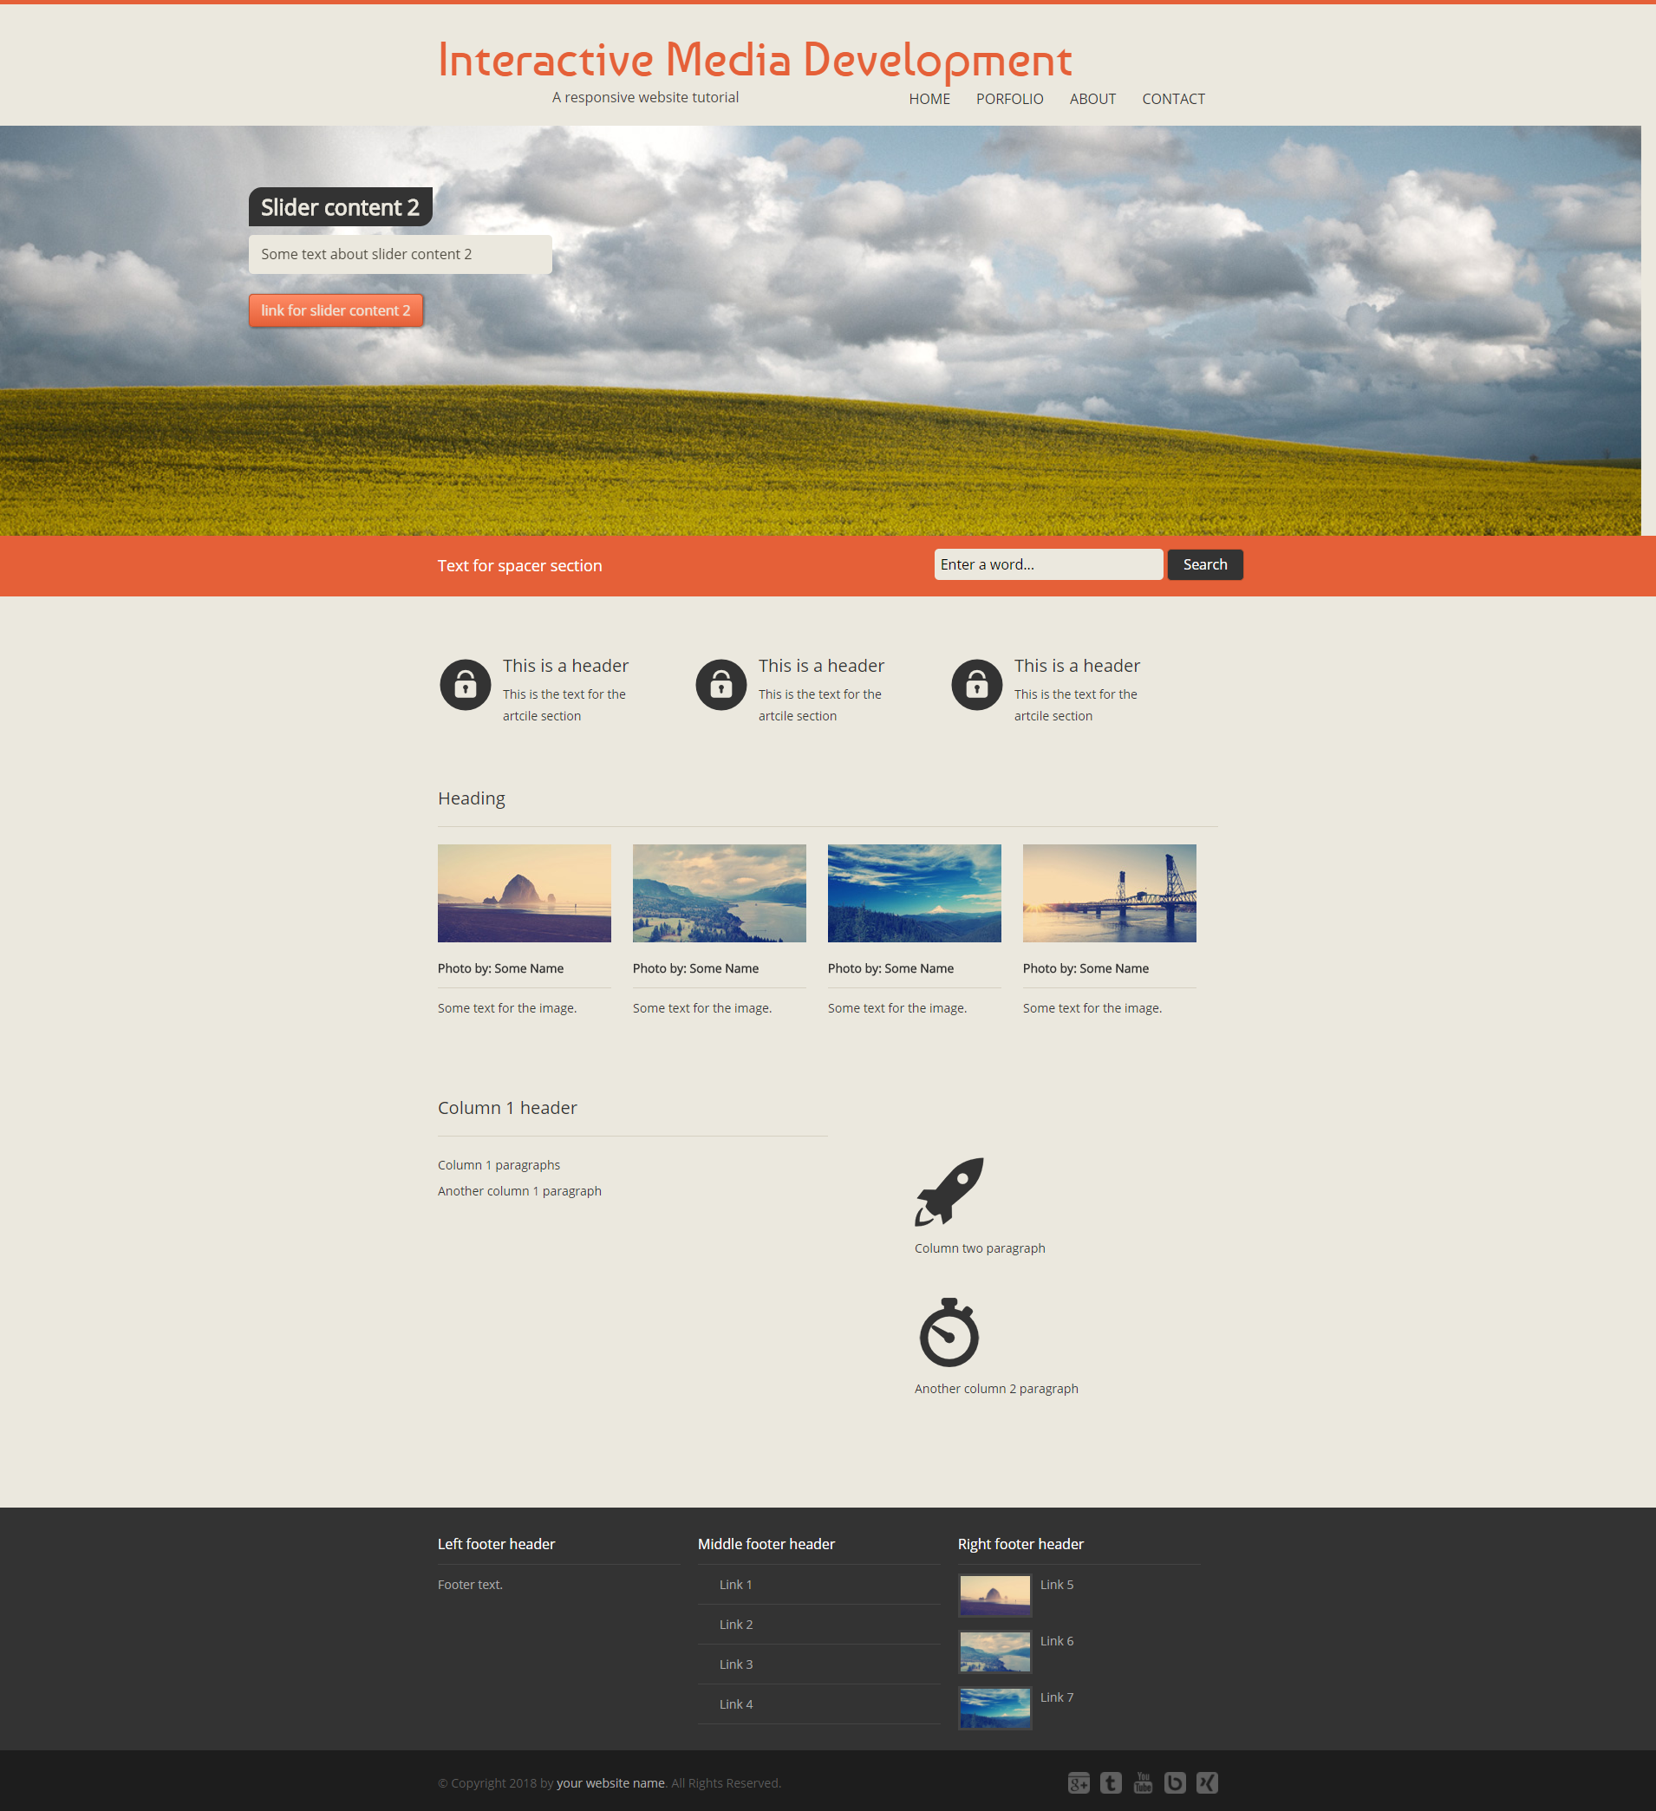

Figure 2 Visual mockup of our intended site

I recommend to always draw a layout before starting to build a website. Having this overview of our structure will make it a lot easier to create the page.

## Let’s start coding

The first thing we need to do is some file management. File management is VERY important in web development! Be organized and consistent and you’ll have an easier time. When creating folders or files, keep an eye on case sensitivity. A folder called images is different from a folder called Images in the eyes of DreamWeaver and web browsers. Similarly, if you’re trying to display and image called cat.jpg but the actual file is called Cat.jpg, you are going to have issues.

### Creating the site in DreamWeaver

Create a folder in your area called “ResponsiveSite”. Inside the “ResponsiveSite” folder create another folder called “images”. Open Dreamweaver CC. We’ll now create a new site. In the top menu, select site > new site.

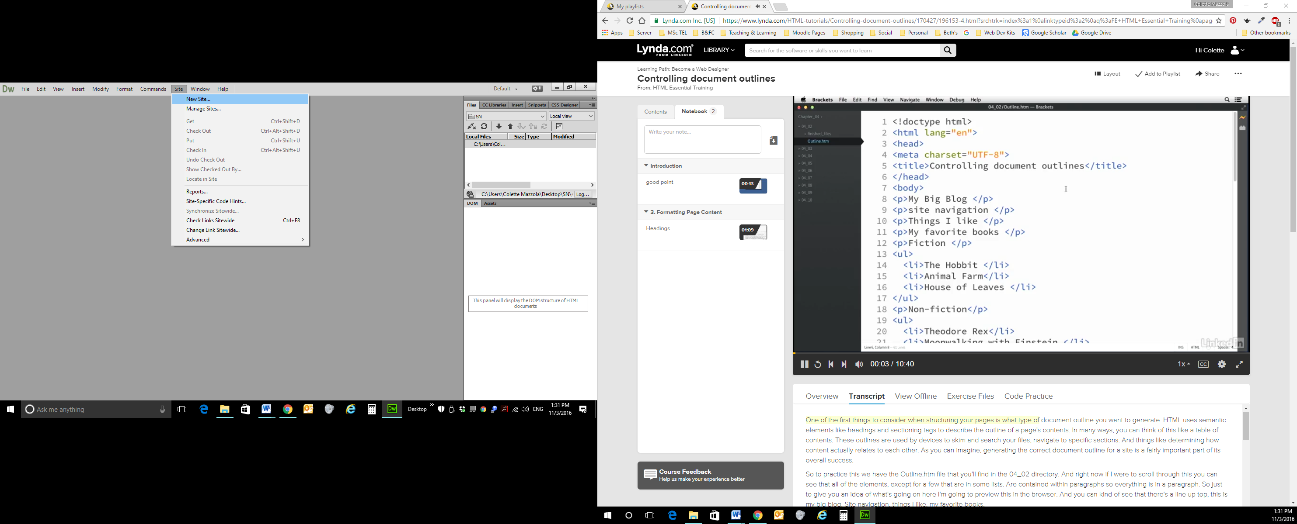

Figure 3 Creating a new site

This areas allows you to access your files from your local computer and it is really useful so let’s do it! Set up a Site name I recommend “ResponsiveWebsite”. Then select the folder 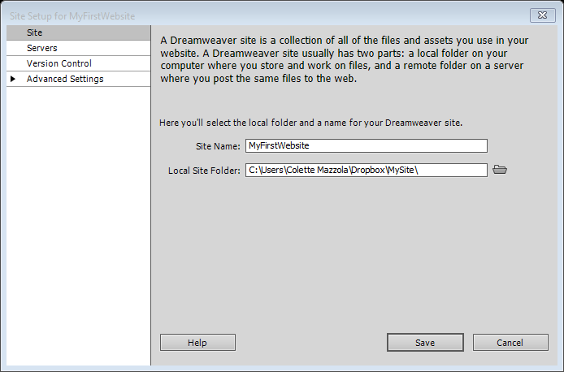 and navigate to your website folder that we just created. Then click SAVE.

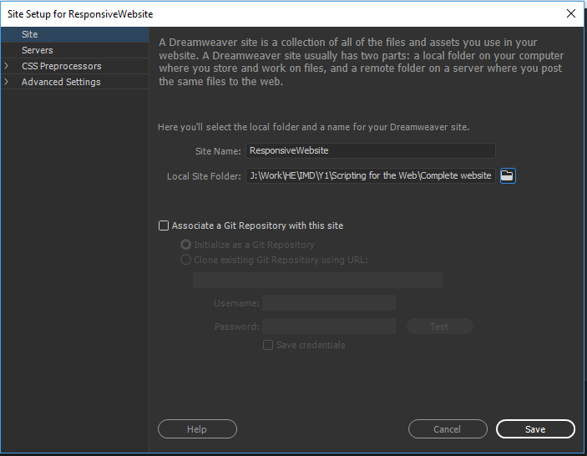

Figure 4 Linking your site to your local folder

What did this actually do …… well this created a shortcut to all your files and folders in the top right hand side of Dreamweaver. (If your page is not the same/ similar as below please see your tutor)

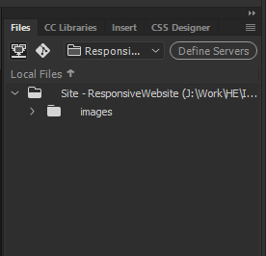

Figure 5 Local file structure

### Creating index.html page

Next we are going to create out first HTML page! On the right hand side where you have set up your folder structure, right click on the top folder and select “New File”. This will create a new HTML page. Change the name to index.html.

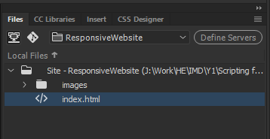

Figure 6 Creating a new index.html

Now double click the file and you should see the code DreamWeaver has already populated the file with. Make sure you have Split selected at the top.

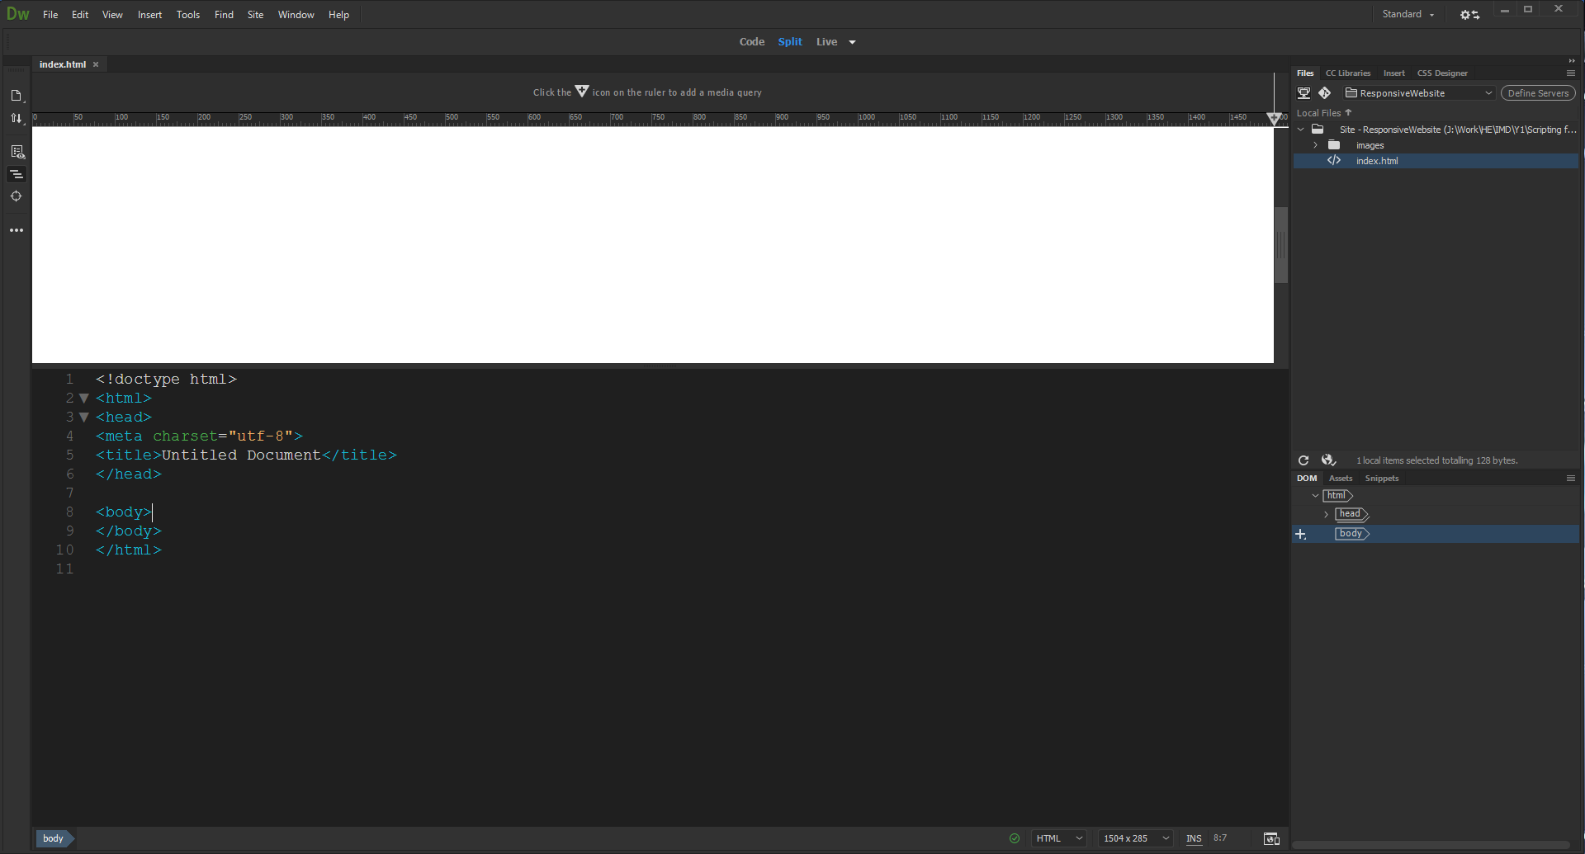

Figure 7 Default HTML file contents

As we would like to create a responsive design which should work on all kinds of devices and screen resolutions we need to add the viewport meta tag to the head section which defines how the website should be displayed on a device. We set the initial-scale to 1.0. What this does is set the initial zoom level to 1.0. That way the page content will be displayed 1:1, an image with a size of 350px on a screen with 350px width would fill out the whole screen width.

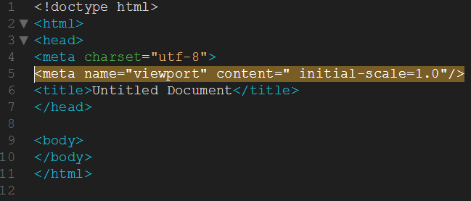

Figure 8 Setting initial-scale

Some people say not to use initial-scale at all as it might lead to incorrect behavior in iOS. In some cases a zoom bug occurs when rotating the device from portrait to landscape. As a result users have to manually zoom the page back out. Removing the property initial-scale might sometimes fix that bug. If it does not there is a script which disables the user’s ability to scale the page allowing the orientation change to occur properly – I’ll let you research that if you find this bug!

### Creating the head – CSS files

In our website we will use four different CSS files. In DreamWeaver, right click the top folder and create a folder called css.

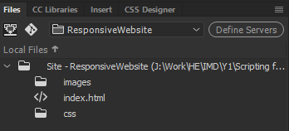

Figure 9 Create css folder

The first stylesheet is called reset.css. What it does is reset the styling of all HTML elements so that we can start to build our own styling from scratch without having to worry about cross-browser differences. For this tutorial I used Eric Meyer’s “Reset CSS” 2.0, which you can find [here](https://meyerweb.com/eric/tools/css/reset/reset.css). On that page, click anywhere on the code, choose save as and save the file into the css folder you just created. Now right click on the files area of DreamWeaver (see above figure) and choose refresh local files at the bottom. You should now see the reset.css file in the file list.

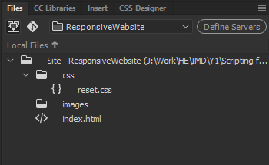

Figure 10 reset.css location

The second stylesheet is called style.css and contains all our styling. We are going to create this, so right click the css folder in the files menu, choose new file and rename it to style.css.

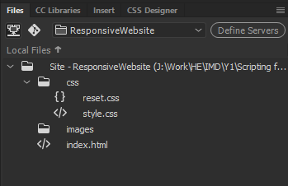

Figure 11 Creating style.css

We don’t want any HTML in this file, so double click the style.css file and delete all the code in the file. Now save the file.

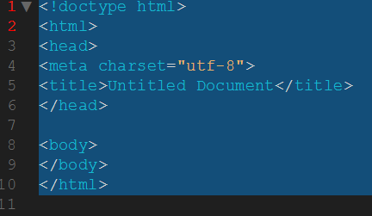

Figure 12 Deleting all code in the style.css file

For our website, we are going to have any of the image ‘blow up’ when we click them. The script we use to achieve this is called Lightbox2 and is an easy way to overlay images on top of the current page. For this tutorial you will need to download Lightbox2 and include the CSS file “lightbox.css”. Download lightbox 2 from [here](https://github.com/lokesh/lightbox2/archive/master.zip), unzip it somewhere. Now go into the lightbox2-master folder > src > css and copy the lightbox.css file to your css folder. Right click in the files menu and choose refresh local folders like before to ensure you;’ve copied over the lightbox.css file successfully.

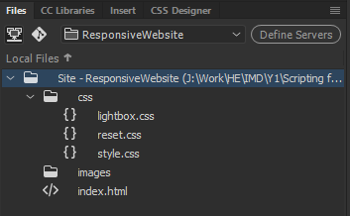

Figure 13 lightbox.css file present

The last stylesheet (Google WebFonts) will let us use the fonts Open Sans and Baumans. To find fonts and include them into your project visit Google Web Fonts. We don’t download the css files, we just link to their location on the internet. So, let’s do that now and link to the file we just downloaded.

Double click the index.html file in the files window and add the following code. While we’re there, let’s also change the title of our page.

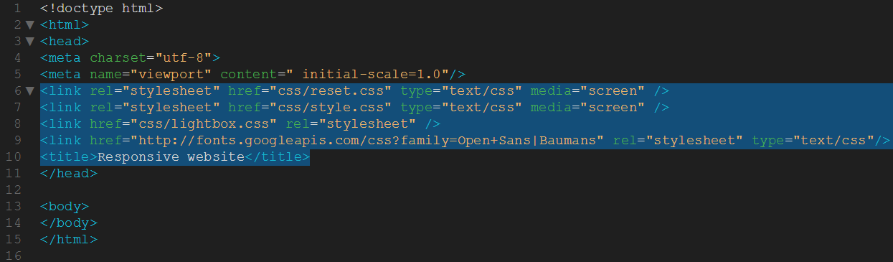

Figure 14 Linking the stylesheets

Please note that when using multiple CSS and JavaScript files the amount of HTTP requests increases which results in longer page loading time. For the live version of your website you could combine all CSS and JavaScript files into a single one. If you know that you are not going to change your CSS code again then this would be a good solution. If you however want to be able to change your CSS and JS files from time to time I would recommend not to combine the files manually as this will probably make things confusing and more difficult to look through.

### Creating the head – JavaScript / jQuery files

Now that we have included the CSS files let´s add all the required scripts. As we are using HTML5 and CSS3 features we need several scripts to make the features visible in all browsers. Create a folder in your ResponsiveWebsite folder and call it js.

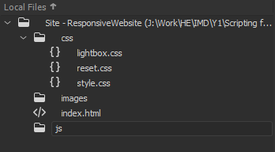

Figure 15 Creating the js folder

The first script we will be using is Modernizr.js, a feature detection library for HTML5 and CSS3. It lets you easily detect whether a browser supports a specific feature or not. Modernizr.js also comes with html5shiv which enables HTML5 elements in Internet Explorer. To download Modernizr.js click [here](https://modernizr.com/download?setclasses-shiv) and click on the large “Build” button in the top right corner. Then click on “Download” next to “Build” and save the file to the js folder you created.

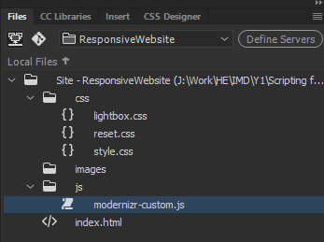

Figure 16 modernizr-custom.js file

The second script we need is Respond.js, a script which enables responsive design in Internet Explorer and other browsers which don´t support CSS Media Queries. Click [here](https://github.com/scottjehl/Respond) to download it from GitHub (click the green ‘clone or download’ button then select download zip). Unzip the folder then navigate to respond-master > src and copy the respond.js file to your js folder.

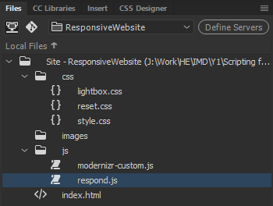

Figure 17 respond.js file

To be able to use i.e. lightbox.js we also need to include the jQuery library. The best way to do this is by letting Google host your jQuery file, also called a CDN (Content Delivery Network) and use a fallback in case the Google jQuery file fails to load. First we’ll get a local copy of jQuery from [here](https://jquery.com/) (click the big orange download button and then click the first ‘compressed, production’ link. At the time of writing it is jQuery 3.3.1 but this updated all the time, so don’t worry if the version you download is newer). Save the file to your js folder.

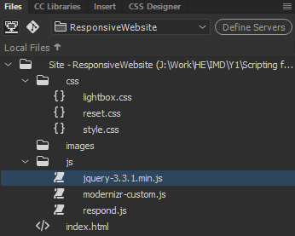

Figure 18 jQuery file

For Lightbox2 we need to include the lightbox.js located inside the js folder in the lightbox directory. We downloaded the Lightbox2 files before. Navigate to the unzipped Lightbox2 folder > Lightbox2-master > src > js and copy lightbox.js to your js folder.

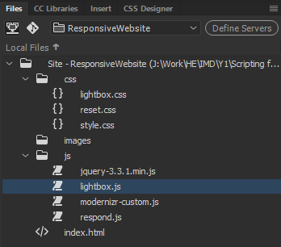

Figure 19 lightbox.js file

In this tutorial we will be using CSS3 features which require the use of different prefixes to work in all browsers. In order not to have to manually define the different prefixes each time we are using a CSS3 feature we will include the script Prefix Free, which automatically creates the required prefixes and lets us write the unprefixed CSS properties. You can download the script from [here](http://leaverou.github.io/prefixfree/) (click the top left hand download icon). Save the file directly to your js folder.

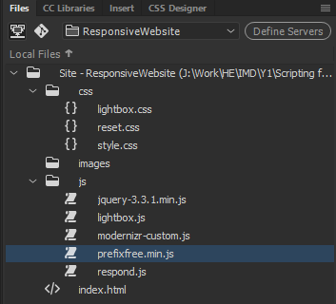

Figure 20 prefix.js file

The last script we will need is for the responsive Image Slider SlideJS. You can download the Plug-In from [here](http://www.slidesjs.com/) (click the download link at the top). Unzip the folder and navigate to Slides-SlidesJS-3 > source and copy the jquery.slides.min.js to your js folder.

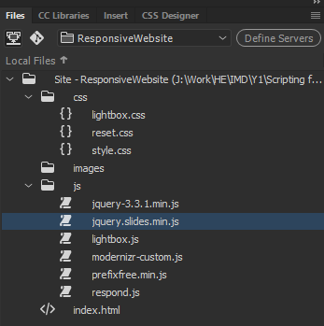

Figure 21 jquery.slides.min.js file

Wow! That was a lot of downloading. Our next step is to tell our index.html file where all those files are, so add the following code to the head section of index.html.

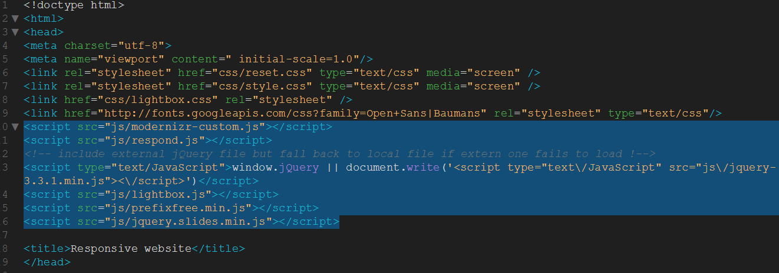

Figure 22 Linking the js files

Remember we talked about the jQuery CDN? No? Well, I’ll remind you. We have a local version but we can use a CDN to load it from. Click [here](https://code.jquery.com/) to go to the jQuery CDN site. Now click the first minified link.

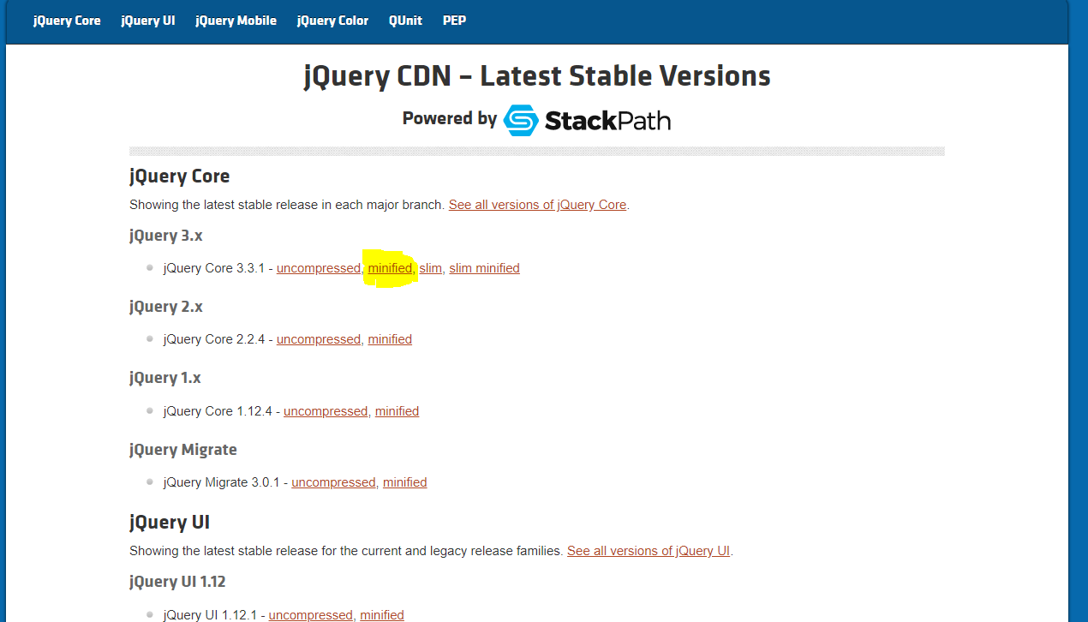

Figure 23 jQuery CDN

Click the clipboard icon on the right and the code will be copied to your clipboard.

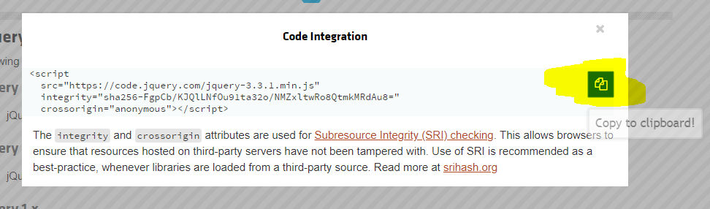

Figure 24 Copy code to clipboard

Now insert that code under the comment in the head section.

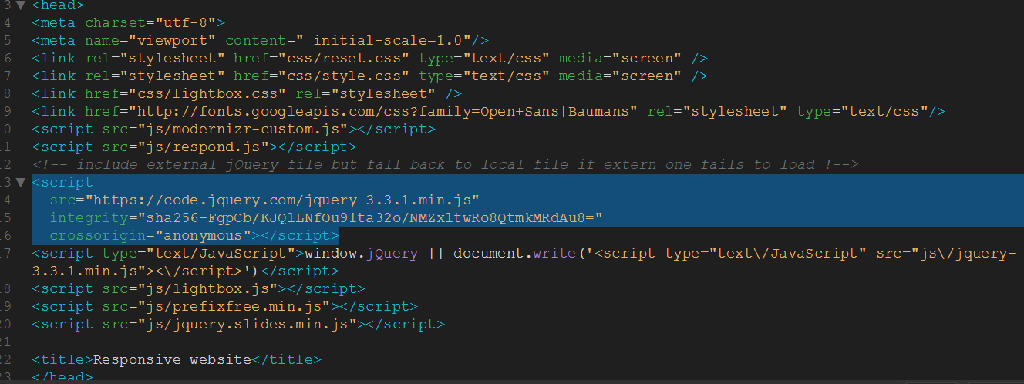

Figure 25 Linking to the jQuery CDN

And that’s it for this section. We now have the required CSS, JavaScript and jQuery file linked so we can now start building something that resembles a website!

## Creating the body – Introduction

HTML5 offers several new elements which help us create more structured and accessible web pages. One of the main advantages of HTML5 is the possibility to structure your web page and tell screen readers or search engine bots what is on a page which helps them to read only the parts they want.

Before we start coding let´s first have a look at the most important new sectioning elements in HTML5.

The new section element defines a part of a website with related content. It should not be used as a generic container element or for pure styling purposes. In that case rather use a simple div.

An article defines an independent piece of content which should be able to stand alone and still make sense.

A header defines a header for a document or a section.

A footer is used for defining the footer of a document or a section.

A nav defines a set of navigation links which should be the main navigation of your website.

An aside defines a section with secondary content. If an aside is placed within an article the content should be related to that specific article. If it is placed outside an article the content should be related to the site as whole.

Each of the sectioning elements in HTML5 should almost in any case contain a heading. By giving each section a specific heading, you are creating a new section in the HTML5 outline. This is important as a proper outline does not only improve accessibility but is also good for SEO. In case you see an “Untitled Section” which corresponds to a section element in your HTML code you might want to specify a heading for the section. For further information on the document outlining algorithm be sure to check out Derek Johnson´s [blog post](https://coding.smashingmagazine.com/2011/08/html5-and-the-document-outlining-algorithm/).

But wait a minute, “Didn´t he just say that we need a heading for each sectioning element? Why would you have headings in the the navigation, the footer or some other sections where you don’t want headings?”. Obviously displaying a heading for each of the sectioning elements does not really make any sense.

On the other hand we need to define headings for every section to create a proper outline. Not using sections in our document at all would somehow destroy the whole purpose of a HTML5 structured document.

A solution for this is to add headings for each section into your HTML code and then hide them with CSS. You should not hide them with display:none though as this would also remove them from the outline. Rather use the CSS property clip to hide the headings which is also the best way not to get banned by search engines for hiding content. If you would like to read more about it check out this answer.

### Creating the body – Building the website structure

Let´s start creating the HTML5 elements on the basis of our layout overview we saw at the beginning of this tutorial.

The first thing we need is a header. The header will include our navigation and our logo. Inside the header we put the main heading h1 and a paragraph. The main heading could be your website´s name or logo and the paragraph a motto or phrase describing the website. Depending on whether the subheading contains the main keywords and is an important part of the site you might in some cases also use a h2 instead. Apart from the heading and the paragraph let´s also put our navigation into the header. Inside the navigation section we put an unordered list with all the navigation links as list items. This all goes in between the header tags, enter the following code:

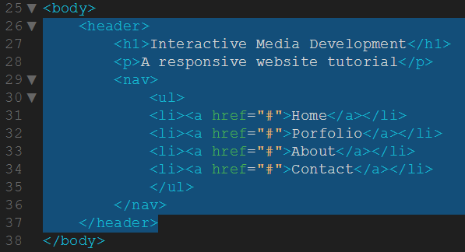

On the website structure layout, the next area below the header is called “Slider-Images”. This area will contain a large jQuery image slider which changes the image every 6 seconds. There are plenty of jQuery Sliders out there but in this tutorial we will use the responsive slideshow plug-in SlideJS which we downloaded earlier.

As you can see in the example files of SlideJS the Slider needs a new div called “slides” which contains the images you want to be slided. As we are going to show content boxes on top of the images we will wrap the div “slides” into a new section “container” and add the content for each image into a separate article which we call “slider\_content1”, “slider\_content2”, “slider\_content3″… We are using IDs instead of classes here because we want to address each article with jQuery later on and need to be sure that each one appears only once on the page. The reason why we used articles for the first three sections and then a simple div for the slides is that the articles contain our independent content while the div only contains our three slider images and mainly has a styling purpose. If you are looking for royalty-free images that you can use in your web project please visit Open-Image.net.

Beneath the header section, add the section for the slider as follows:-

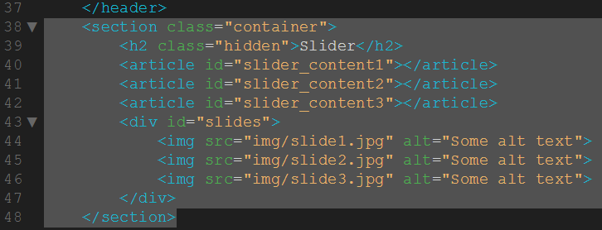

Figure 26 Adding the slider section

Now let´s add the slider content into our markup. “slider\_content1” will be the content which is shown when the image “slide1.jpg” is displayed, “slider\_content2” for “slide2.jpg” and so on. Inside these articles let´s add a heading, some teaser text and a read-more link. Note that we also add a heading with a class “hidden” into the section as we want to create a proper HTML5 outline. If you have problems deciding which heading to use on your website my recommendation is to try to use a heading structure with elements of the appropriate rank for the section’s nesting level. Read [this article](https://coding.smashingmagazine.com/2011/08/html5-and-the-document-outlining-algorithm/) if you would like to know more about proper use of headings in sections. So add the following code to your slider section:-

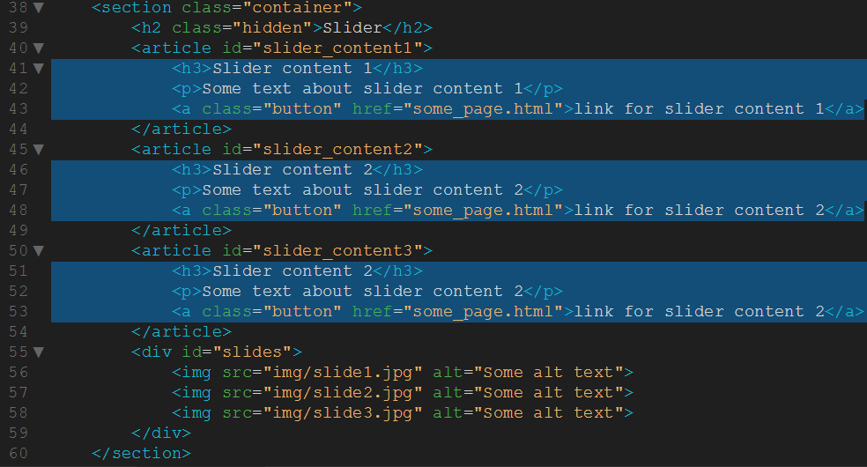

Figure 27 Adding text and links to each article section

Now that we have the HTML structure of the image slider let´s move on to the next element on our structure layout. As you can see the next thing to do would be the spacer. I called it spacer although it is not actually a spacer, it is just some orange part below the image slider with a short sentence and a search field. For the spacer we use a new section with the ID “spacer”. The reason I used an ID instead of a class for all the sections on the website is that I would like to be able to directly link to a specific part of the website (e.g. http://www.<your-domain>/#spacer directly scrolls down to the spacer). Inside the spacer we put a short sentence into a new paragraph and another div with the class “search”, which contains our search form. Enter the following code below your slider section :-

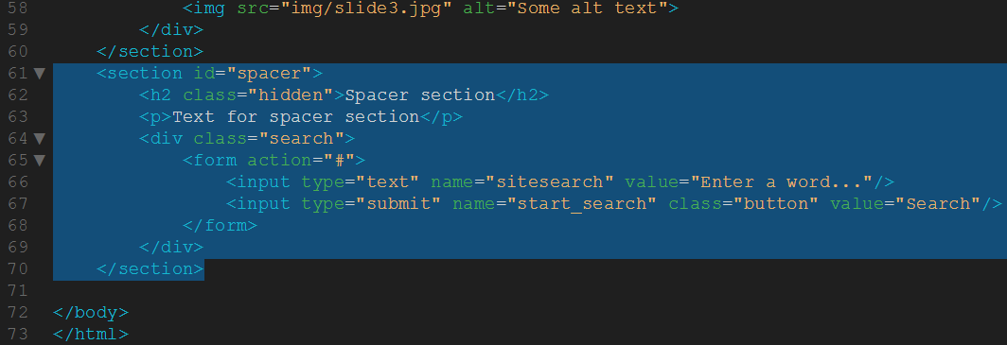

Figure 28 Adding the spacer section

You are doing great, we already have almost half of the whole HTML5 code we need. Take a look at the structure layout again. You can see that from now on we have almost only “articles”, which are wrapped inside containers.

Let´s continue with the next section which contains three articles with a heading and an icon next to it. We add a heading h3 and a paragraph p with some text to the articles. The br class=”clear” is used to clear the floating of the three articles which we will add into our CSS file in the next part of this tutorial. Add the following code below the spacer section :-

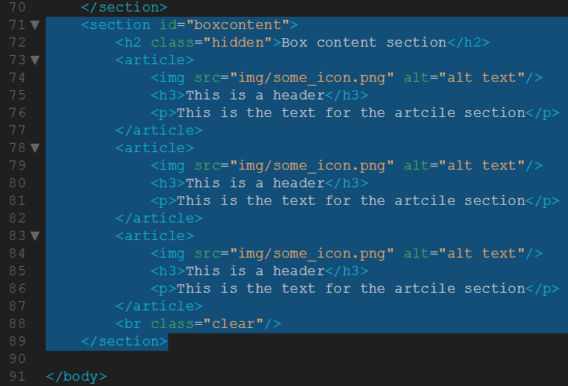

Figure 29 Adding the box content section

Now let´s create our next section again with a h2 heading and four articles in it. Inside the articles we put a hidden heading h3 and a new HTML5 element called figure. The figure element is used in conjunction with the figcaption element to mark up images or diagrams (among others) and should be an independent part which can be moved away from the main flow of the document. We create a figure element and add an image and a figcaption to it.

To enable image resizing we also need to create an anchor around our image and give it the attribute rel=”lightbox”.  The href attribute should point to the large image version. We also include some span elements which we will use for styling in the second part of this tutorial to make it invisible by default and only show it on mouse hover. Add the following code below your box content section - take your time – there is quite a bit:-

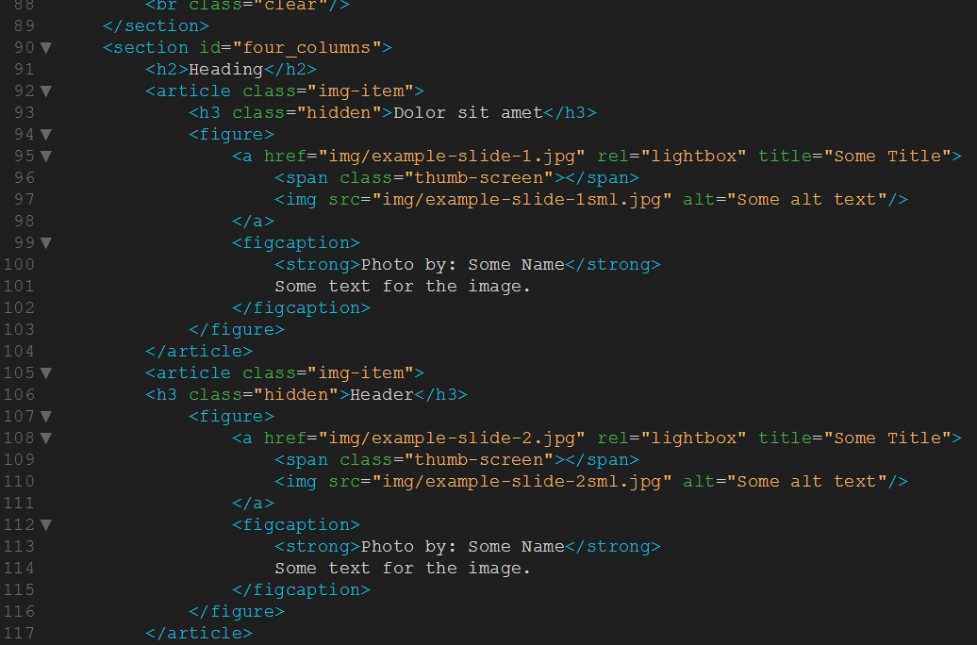

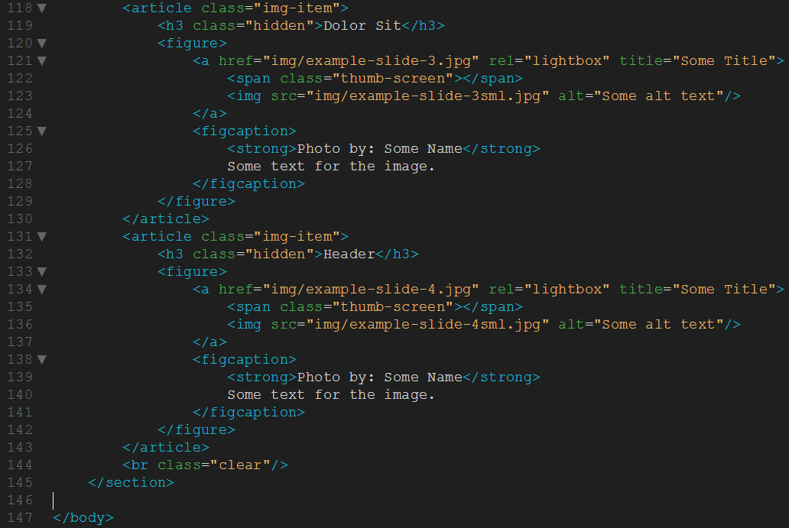

Next thing we need is another section with a hidden heading, an article and another section in it. The second section contains a hidden heading and two articles which each contain also a hidden heading. Give the outer section an ID, for example “text\_columns” and each of the columns a class, for example “column1” and “column2”. We could of course also not use classes and address the article and section directly. The reason I like to use classes though is that it makes it easier in case you want to change the HTML code later on without having to change the CSS code.

Inside the first column put a heading h3 and a paragraph p with some text. Into the second column we will put two articles or divs depending on whether the content is relevant and independent or not. Inside each of these two wrappers add a paragraph p and an image. The images need a class “rocket” and “clock” and will be animated later on in the second part of this tutorial.

Inside the first column put a heading h3 and a paragraph p with some text. Into the second column we will put two articles or divs depending on whether the content is relevant and independent or not. Inside each of these two wrappers add a paragraph p and an image. The images need a class “rocket” and “clock” and will be animated later on in the second part of this tutorial. So, add the following code below your four columns section:-

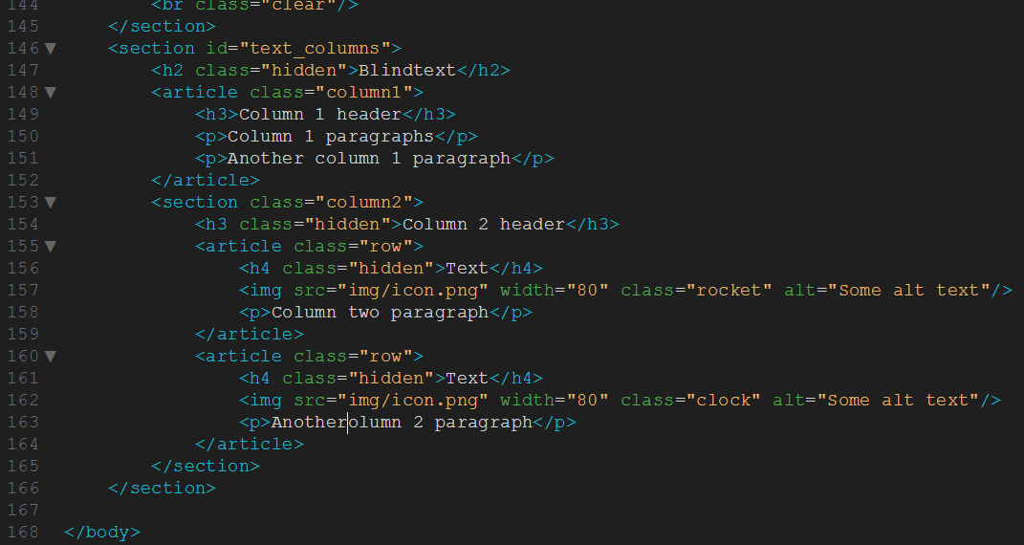

Figure 30 Adding text columns section

We have already reached the footer of our website. Into the footer we are going to put not only a hidden heading and a section with three articles for the upper three columns of the footer but also another section with the ID “copyright” which we are going to position at the bottom of our footer later in the second part of this tutorial. Into the “copyright” section we add a div with the class “wrapper” which will make sure the content is centered and does not exceed the maximum width (we are going to talk about that in the second part). The reason we are using a div here instead of an article is that in this case all we need is a container for styling purposes, there is no actual related and independent content inside. Into the “wrapper” div we put a copyright note as blank text and another div with the class “social” which contains all the social links.

The section we create at the beginning of the footer again gets a hidden heading and contains three articles with the class “column”. To the second and third article we need to assign another class so we can later on target each article separately in CSS. Add the class “midlist” to the second article and the class “rightlist” to the third one. To do so simply add a blank space after “column” and put the other class behind (<article class=”column midlist”>). Into the articles we need to add some content, into the first one let´s just put a heading and a text. Into the one in the middle and the one in the right also put a heading and an unordered list with a link inside each of the list items. Each link should be wrapped around an image and a span element. The span contains our text that we want to display. We are using a span to be able to position the text in any way we want and display it as a block element (more about that later). So, add the following code for the footer, below the text columns section  :-

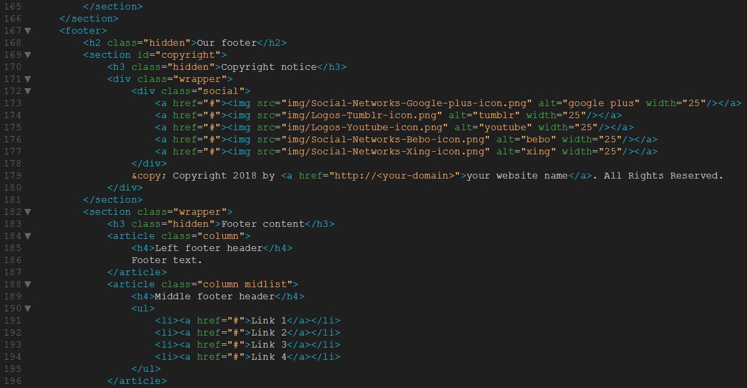

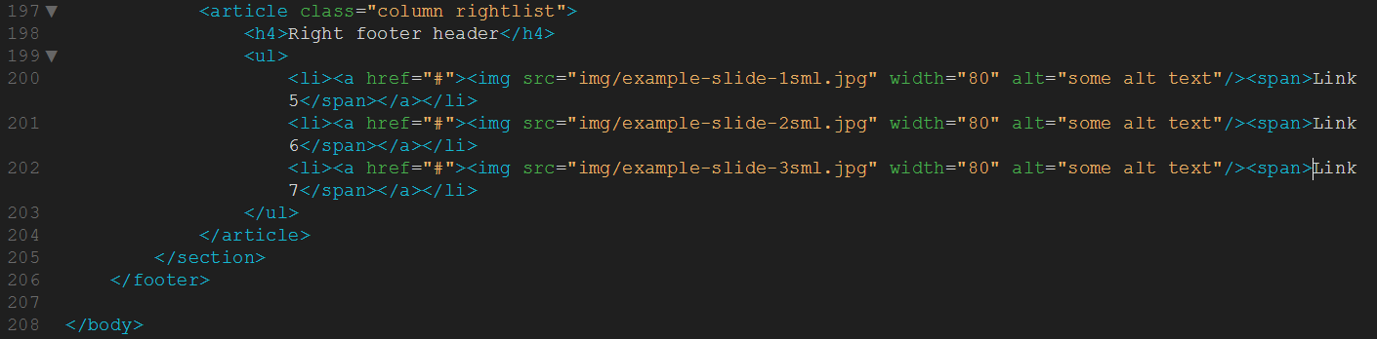

Figure 31 Adding the footer content

Ok, that’s all the code done for the index page. You notice we have a lot of images that we are linking to but we haven’t put any images in the site folders yet, so we’ll do that now. But first a confession. You know I told you to create an images folder? Well, silly me only went and put all the links to the images in the code to point at img, not images. Let this be a lesson to you – file paths matter! To correct this, please click on the images folder in your file window and rename it to img, like this:-

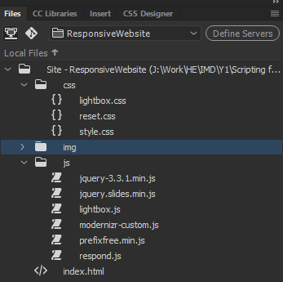

Figure 32 Rename the images folder to img

Now all our image links will point to the right place. Download the below zip file and unzip it somewhere.



Copy all the images to your img folder. Your file menu should look like this after you refresh it:-

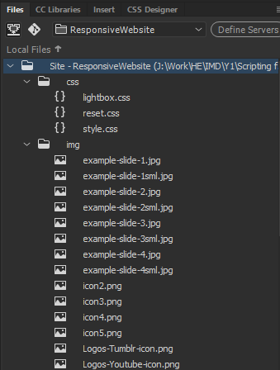

Figure 33 img folder contents

That´s it already! If you really want, you can view the website by opening the index.html file in Chrome, it should look like this:-

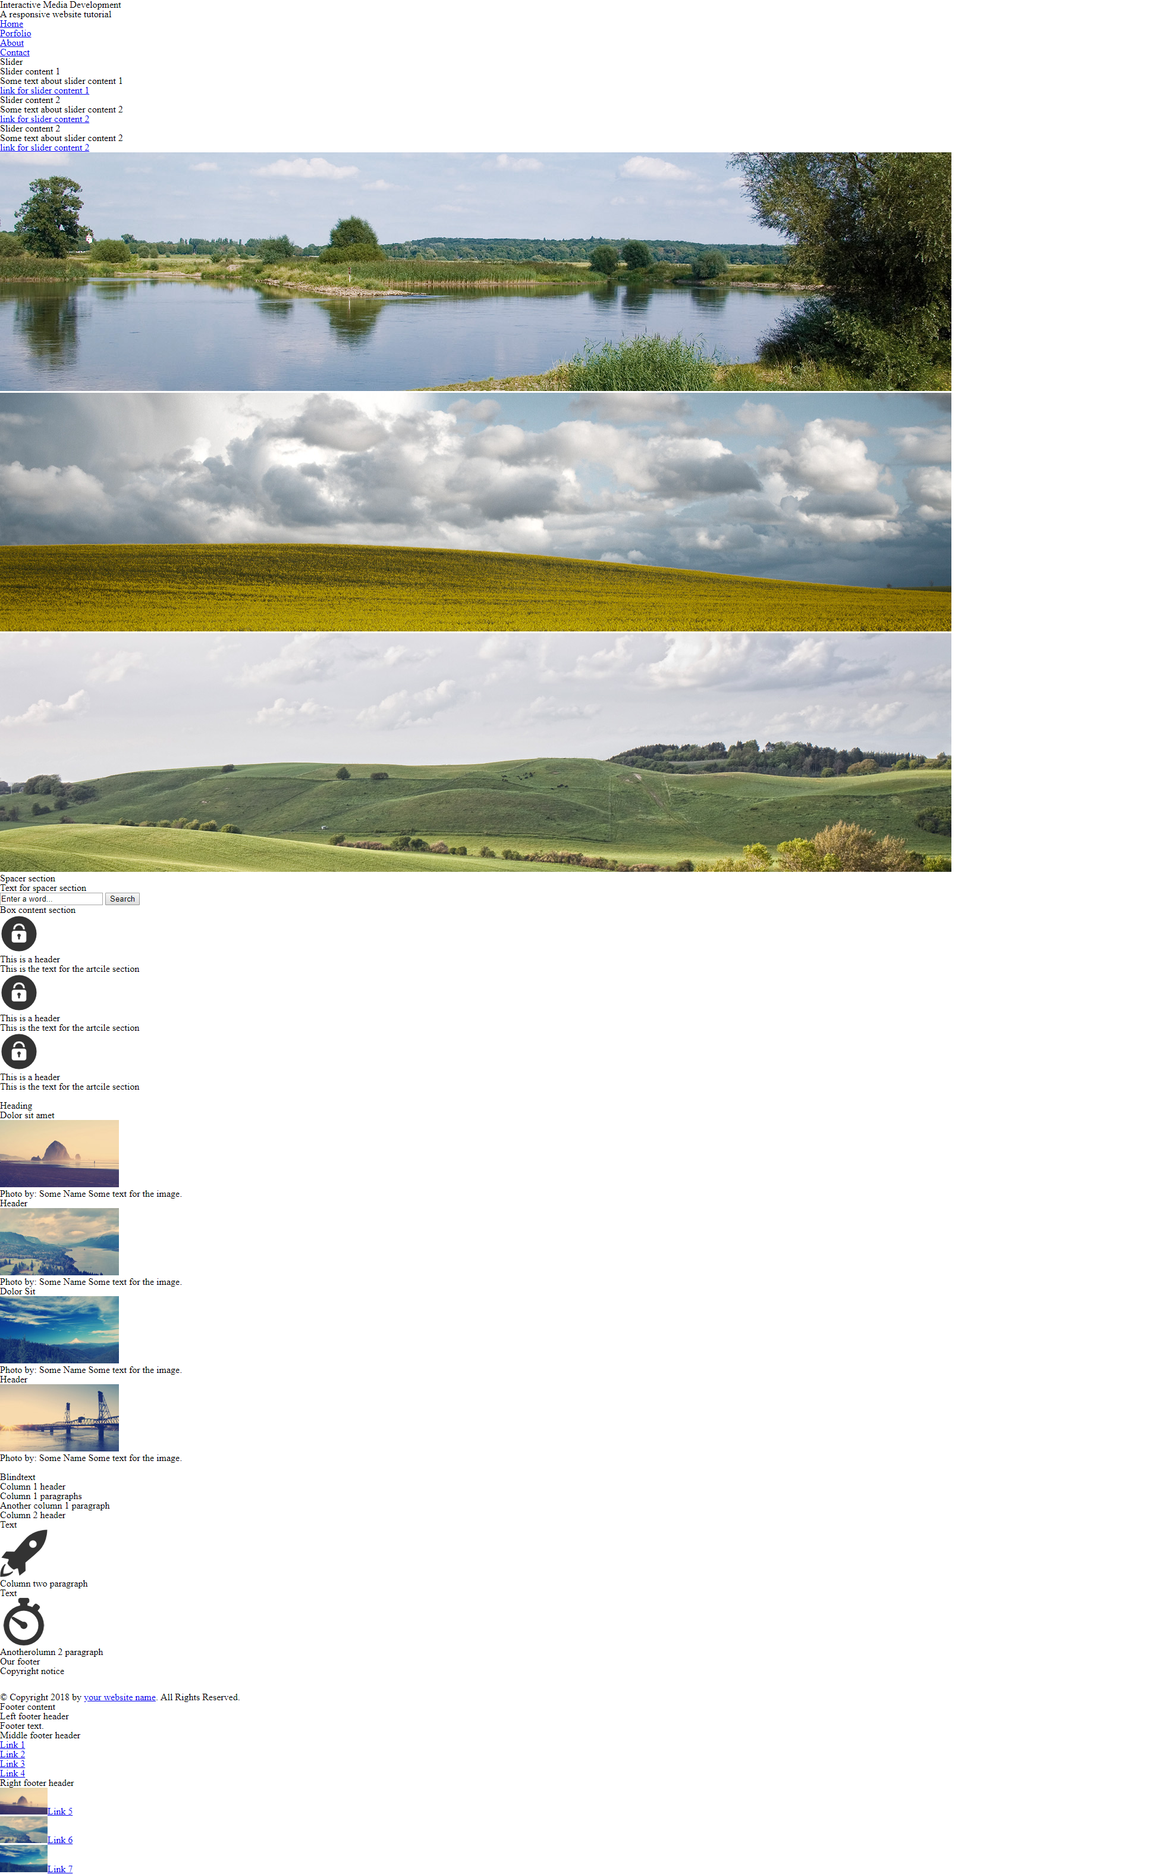

Figure 34 index.html in a browser

Ewwwwww! Why does it look like that? Well, that’s because although we’ve created our content, we haven’t styled it. Remember, that’s the separation between HTML5 and CSS3 – HTML5 is for creating content and CSS3 is for styling that content – i.e. making it look pretty!

In the second part of the tutorial we are going to style our website to make it look like an actual professional websitebut we are also going to add some more HTML code when it comes to responsive design.

I hope you liked the first part of the tutorial, please feel free to tell me how you found it or if you think we can make any improvements. Before you continue with part 2 though, take a well earned rest and grab a coffee, and remember, if you’re passing the cake shop, I do love a jammy doughnut!

# Part 2

In this second part of my tutorial we will be building the CSS and do the necessary steps for responsive web design to create a beautiful HTML5 responsive website. Be sure to have worked through the first part of the tutorial where we built the basic HTML structure and included all necessary scripts.

We have already included our CSS Reset in the last part of the tutorial. The Reset will take care of any differences in the default styling of HTML elements by simply resetting all the CSS values. That way we can start creating the styling from scratch but we need to have in mind that paragraphs will no longer have a browser predefined padding so we have to manually define every value.

## Creating the styling – Defining the global rules

When creating the stylesheet it is important to always use comments for the different sections of the CSS file. The first section is the global or general section where we will put all styling which are used on your whole website and mostly remain unchanged. The first element we are going to style is the body element. The first thing we do is place an orange stripe on top of the page. This stripe is created by a 5px thick top border defined in our body element rule. Let´s also define our website background color and our general font family and font color. In your file menu, double click the style.css file and enter the following code in it:-

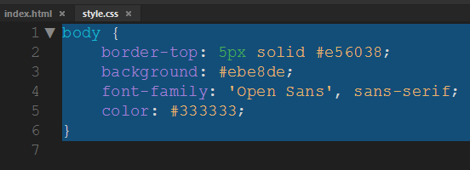

Figure 35 Creating the body style

Save the css file and preview the index.html file in Chrome. As we’ve added styling, the look of the page should change already. It should look like this:-

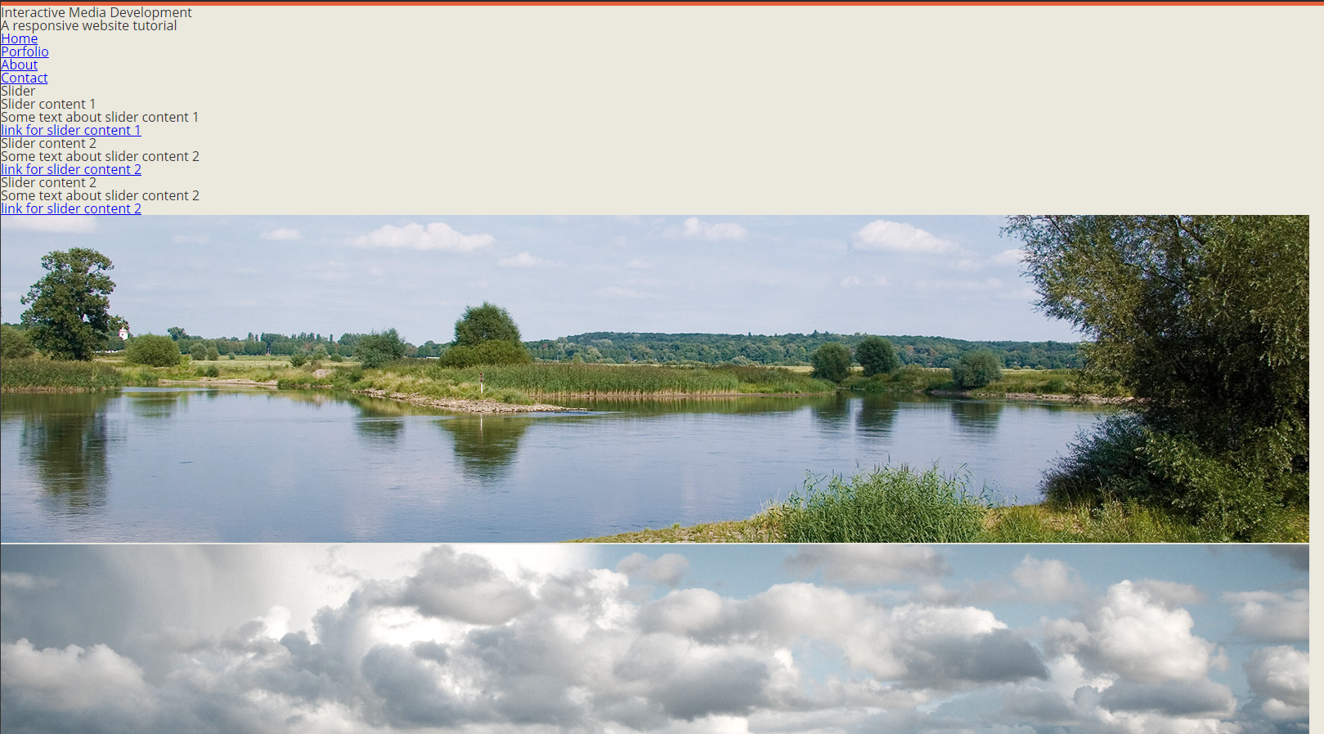

Figure 36 Testing the styling changes

It’s always worth testing any styling changes so we can catch bugs and typos straight away.

The next element we want to style is our input fields. As we would like the input fields to look the same on any further page of our website we will put the input styling into our global section of the CSS file. In our website layout we only have two different kinds of input fields: a text input field and a submit button. Due to that reason we will create a general input rule which will cover the styling for all the different kinds of input fields and a second rule only for our submit button.

If you look at the CSS code for our input fields you will probably note that we are using CSS3 features without defining prefixes for the different browsers (-webkit, -moz etc.). As already mentioned in the last part of this tutorial we use a script called **Prefix Free** which automatically rewrites the CSS rule depending on the browser used by the visitor. That way we can use CSS3 properties by simply adding the general rule (e.g. just box-shadow instead of -moz-box-shadow, -webkit-box-shadow and box-shadow). Add the following code below the body element:-

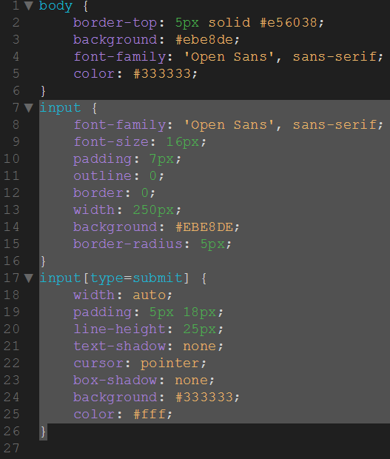

Figure 37 Defining the input field and submit button styles

Next let´s add rules for our paragraphs and anchors. As we have removed all styling by using the reset.css we now need to define our margin (or padding) and line-height manually for the paragraphs. The anchors should inherit their font color from the parent element and change it by fading it from one color to another. To do so we use the CSS3 feature transition. Since we have removed all predefined CSS styling we also need to define our strong elements. In our case they should just be displayed in bold. Add the following code to the bottom of the style.css file:-

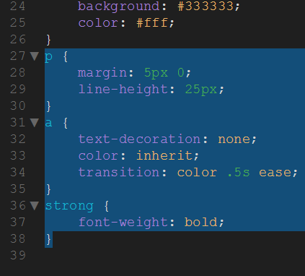

Figure 38 Defining the p, a, and strong styles

We have three rules left in our general section of the CSS file. The first one is the rule for our figcaption  element. As mentioned in the previous part of the tutorial a figcaption  is useful in conjunction with the figure element to mark up images or diagrams. In our website the figure element is used for our four little images. To emphasize the heading of our caption a bit more and to add the line between caption title and caption text we will now add a CSS rule for our strong element inside the figcaption. Add the following code at the bottom of the style.css file:-

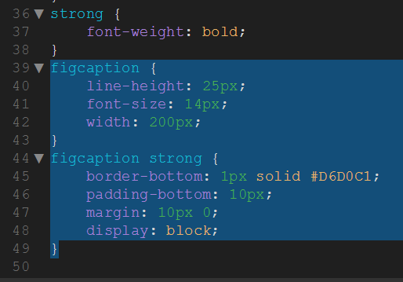

Figure 39 Defining the figcaption styling

### Creating the styling – Defining the section rules

Now that we have finished creating the general CSS rules let´s start defining the rules for our different sections of the website from top to bottom. To make our website responsive we will set the width property to auto and define a max-width of e.g. 900px for each section on our website. What this does is leave the sections at 900px width when the browser window is wider than 900px. However when the browser width gets smaller than 900px the width of our sections will adapt to the browser´s width.

As we would like the sections to be horizontally centered we will set the margin-right and margin-left property to auto. Centering elements like that is however not supported in Internet Explorer 5. As a solution you could set the body element´s text-align property to center. I personally won´t even bother as IE 5 is almost not used anymore at all.

Let´s start creating the rules for our different sections of our website. The first section to style is our header. On a real website with several pages you might have multiple header elements so you would need to give the main header a class or an ID to create specific rules only for that element. In our case though since we only use one header element on our entire website we will just add a rule for all header elements and a rule for all paragraphs and h1 headings inside a header. Add the following code to the bottom of the style.css file:-

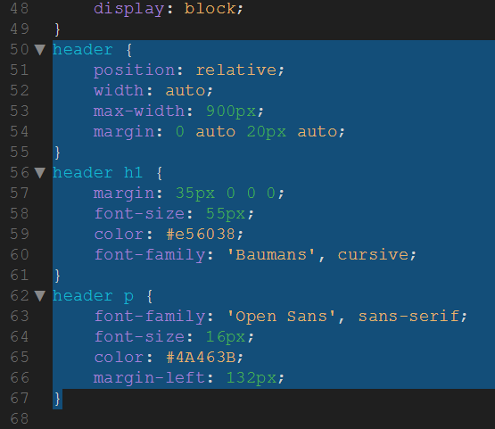

Figure 40 Styling the header section

Save the style.css file and preview the index.html file in Chrome. It should look like this:-

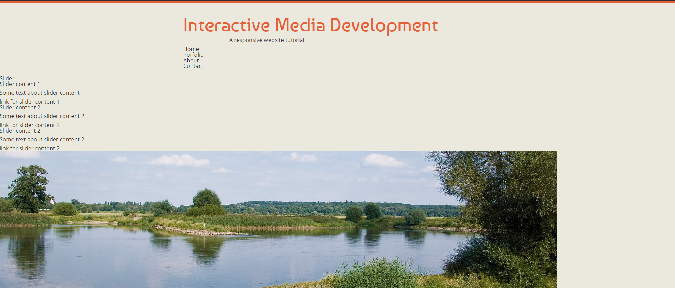

Figure 41 Index.html preview with header styled

Pretty cool eh? Well I think it’s cool. You can see how as we’re adding our styling the website is starting to come together. Let’s carry on.

For our main navigation we used the new HTML5 nav element. Since we have added the CSS property position: relative to the header element we can now use position: absolute to position the navigation at the right bottom corner of our header.

Our list items should not be positioned one below the other but next to each other. To do so we will make each list item float and add a padding to create a space between each of them. For the anchors within our list items we will define a font type and color and set text-transform to uppercase to make all letters uppercase. We also add a transition of 0.25 seconds and define a color in the hover state. This way the links will fade from one color to another when hovering them. Add the following code to the bottom of the style.css file:-

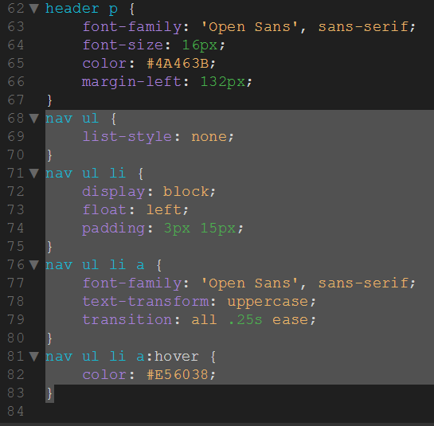

Figure 42 Styling the nav bar

The next section to style is our slider-image section. Just like in the example file of the Slides script we set the container width to auto to make the slider images resize depending on the browser´s width. The div “slides” needs to be hidden with CSS as it will be made visible by the Slides script. Also add a border to the div with the class “slidesjs-container” to prevent the slideshow from flashing on load. Our slider content is positioned absolutely within our slider container and gets a z-index higher than the one from our container to make it overlay the slider images. As we want to show only slider\_content1 at the beginning when loading the site we will set display to none for all slider content boxes except of slider\_content1. Add the following code at the bottom of the style.css file:-

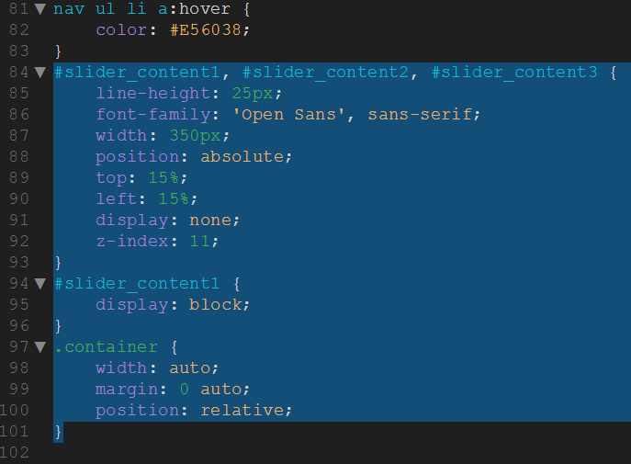

Figure 43 Styling the slider

Now that we have styled the wrapper for our slider content let´s add a styling to the headings and paragraphs inside our slider\_content1, slider\_content2 and slider\_content3. To create the effect of two rounded borders simply add 0 to the borders you don´t want to be rounded into our border-radius property. The order for the values inside that property are top-left, top-right, bottom-right, bottom-left.

For our property display we choose inline-block which displays our headings inline but will preserve the capability to style them just like block elements (setting width and height, margin, padding and so on). The advantage over just using block instead in our case is that the dark background of the heading will be as wide as the heading text itself and not as the surrounding element.

For the paragraphs we will define the same padding as for the heading to make it look in a line and set a bottom margin to create a space between the paragraph and the “Read more” button. You can also set a small border-radius to make the borders of the paragraphs a bit round. Add the following code to the bottom of the style.css file:-

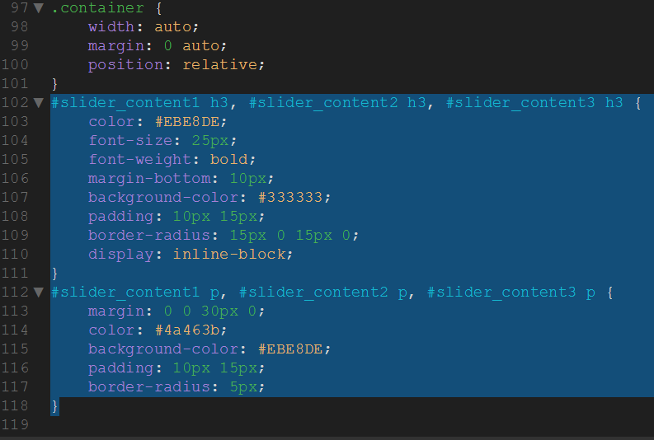

Figure 44 Styling the slider content

If you preview the index.html in Chrome, you’ll see the content for slider 1, but not for slider 2 or 3 – why is that? Don’t worry, that comes later when we implement the jQuery. The important thing right now is that the styling we’re adding is changing things.

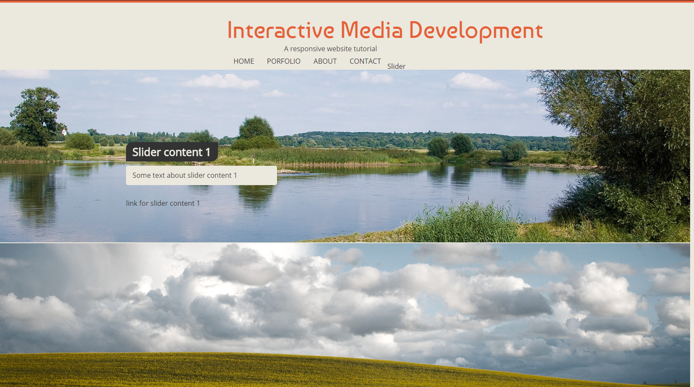

Figure 45 Styling the slider content

Now that we have finished the CSS part of our slideshow let´s move on to the next section, our orange “spacer”. We set the width to auto to make it fill the whole width of the surrounding element (which is our body element).

To position the question text which is wrapped inside a paragraph we can´t just define a fixed percentile value for our left property. If we did so the question would move to different positions depending on the browser´s width and would not stay fixed at a certain position. The solution is to set the paragraph´s position to absolute and the left property to 50% which positions the paragraph in the middle of our spacer. Then add a negative margin-left to move it a bit more to the left side. This way the paragraph will always stay at the same position regardless of the browser´s width. To position our search form we do the same thing. Note that we don´t need to style our form elements as we have already added a general styling in the global/general part of our CSS file. Add the following code to the bottom of the style.css file:-

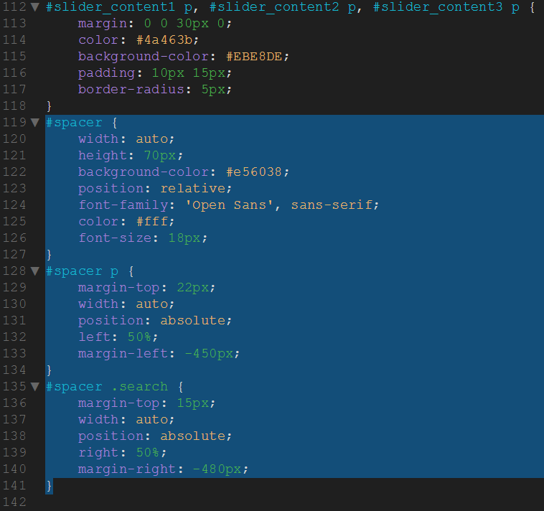

Figure 46 Styling the spacer section

Our next section consists of three articles each with an image, a heading and a paragraph. Again we need to set the width of our “boxcontent” to auto to make the width respond to the browser´s width and set a max-width to limit the maximum width. To make the section centered we again use an auto margin to the left and to the right. To create a little space to the top and bottom we set a padding. As we want the articles to be positioned next to each other let´s make them float, set a fixed width and create a little space between them by setting a margin-right. Inside the articles we let the icon image float to the left in order for the text to be placed directly next to the icon and not below it. By floating the icon the heading will now be placed next to the icon image but the text which is placed in a paragraph will only stay next to the image as long as the image is still there. As soon as the text exceeds the height of the image it will continue at the left border of our article below the icon. To fix this we need to define a margin-left for the paragraph to make it vertically in a line with the heading. Add the following code to the bottom of the style.css file:-

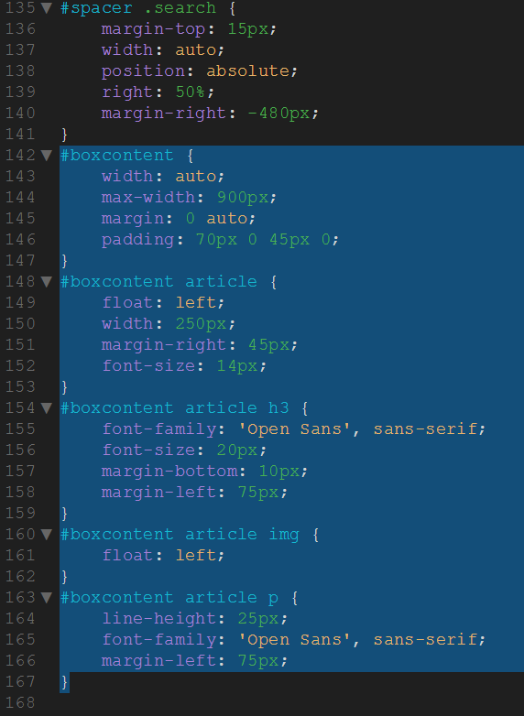

Figure 47 Styling the boxcontent section

For the next two sections we will combine two rules in order not to have to write it two times. For both the section “four\_columns” as well as the section “text\_columns” we set the font, the line height, the width etc. as well as define the styling of the h2 and h3 headings. Add the following code to the bottom of the style.css file:-

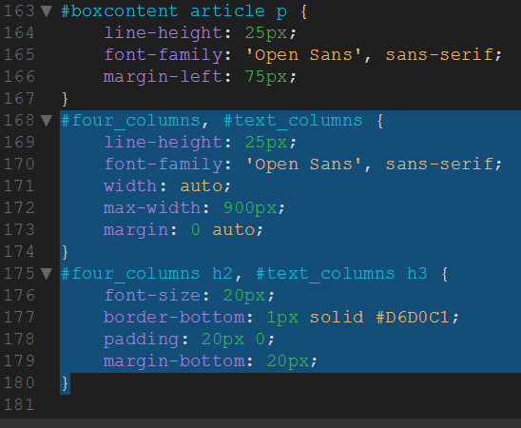

Figure 48 Styling the font within the box content section

Just like in the last section we also let the articles within “four\_columns” float to position them next to each other. To create the effect when hovering the thumbnail images we will first set display to block for the anchors inside our articles. We want them to be displayed as block elements as they should adapt its own size to the size of the elements inside of it and fill the whole height and width of our thumbnail image. We also set the position to relative in order to be able to position the span element “thumb\_screen” absolutely inside of it.

This span element will be displayed on top of our image and shows the little zoom icon and a dark background on mouse-hover. We need to position it absolutely in order to make it lay on top of the image. With a relative position the span element would be displayed above the image. To create the half transparent background we will set the background color to black and add the zoom icon as background image (vertically and horizontally centered). Then we set the opacity to 0 to hide the span element by default. To let the span element fade from invisible to visible we will add the CSS3 feature transition (more about it in my [other blog post](https://www.lingulo.com/tutorials/css/css3-transitions)) for the property opacity. In the hover-state of the span element we set the opacity to 0.5 to make it 50% transparent on mouse-hover. Add the following code to the bottom of the style.css file:-

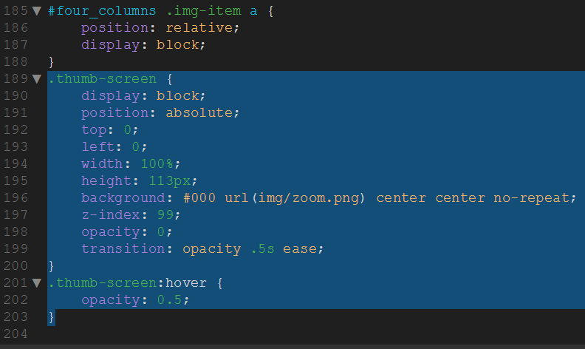

Figure 49 Styling the thumb images

This is probably a good time to test how our site is looking. Previewindex.html in Chrome. It should look like this:-

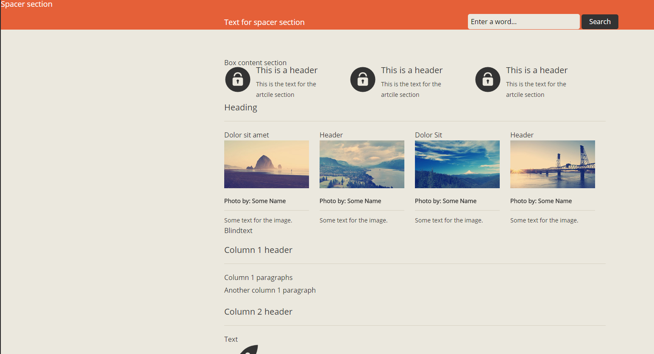

Figure 50 Preview of index.html with box content section styled

The next section consists of two columns, one article and one section which should float next to each other. Each of the two columns should have half the width of the website width of 900px. To move the second column a bit more down to be vertically centered with the first column we define a margin. The section “column2” contains two articles which should each have a relative position in order to be able to absolutely position the rocket and clock icons. Add the following code to the bottom of the style.css file:-

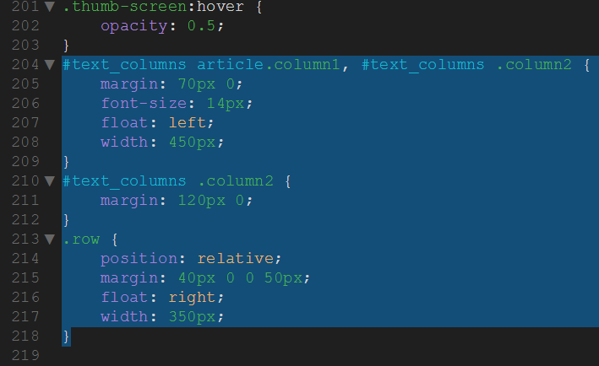

Figure 51 Styling the text columns section

As a little gimmick we will now create the CSS animation which starts when hovering the rocket and clock icon. Whether or not this is a useful feature depends on your site and what you would like to achieve with the animation. Note that CSS animations will not be supported by every browser and might in some cases lead to unexpected behavior (for example the rocket in some browsers might disappear on mouse-hover).

When hovering the rocket we want it to fly to the top right and fade out. So let´s set the opacity to 0 on mouse-hover and define a transition for the opacity. We want it to fade out within 0.4 seconds after a delay of 0.2 seconds. To do so add the delay as last value into our transition property. Now that the rocket will fade out on mouse-hover let´s add the path animation. In order not to have to set all the keyframes manually we will use the tool [Stylie](https://jeremyckahn.github.io/stylie/" \t "_blank" \o "Stylie - A graphical CSS animation tool) to create a path from the bottom left corner to the right top corner. Simply copy the CSS code inside the class “stylie” generated by the tool into our rocket:hover rule. Then create a new section “keyframes” at the end of your CSS file where you add the keyframe rule (the part starting with “@keyframes stylie-transform-keyframes”). You might need to adapt the translateX or translateY property to match the starting point of your rocket with the rocket icon (if you don´t change the values manually your rocket might start not exactly from where the rocket image was before hovering it). Just play around with the values to make it look somehow realistic. Also be sure to set the value for animation-iteration-count to 1 so that the animation will occur only once on mouse-hover and the rocket doesn´t fly infinetely.

For the clock icon we want the animation to look just like a ringing alarm clock. To achieve this we will again use Stylie to create a horizontal path and then set the animation-duration to about 100ms. Also set the animation-iteration-count to infinite to make the animation repeat endlessly. Please note that we need to change the name of our keyframe rule as the name “stylie-transform-keyframes” has already been used for our rocket keyframes. Add the following code to the bottom of the style.css file:-

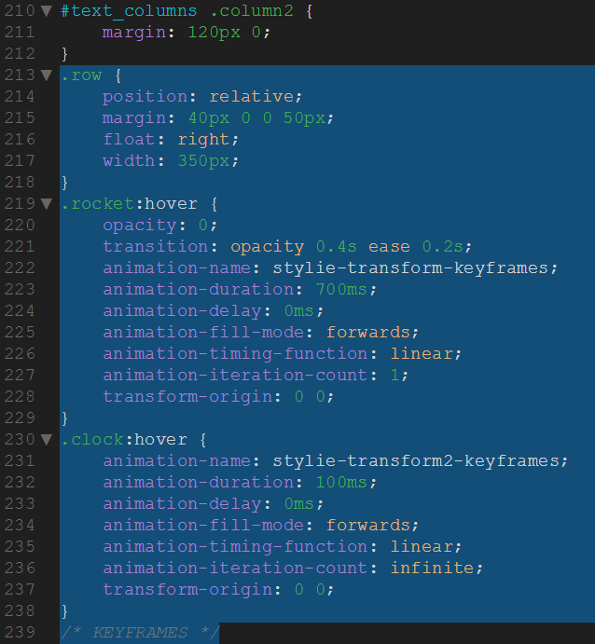

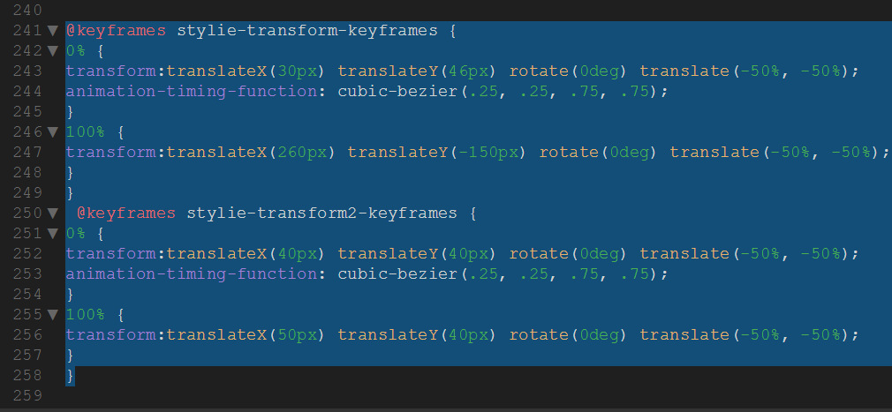

Figure 52 Adding CSS3 transitions

We have reached the footer of our website. As we want it to fill the whole width of the body element and have a fixed height we set the width to auto and define a height value. We also add position:relative again in order to be able to position the copyright section at the bottom of our footer.

Inside our footer we have another section with a class “wrapper” which should have an auto width and a max-width of 900px just like the other sections in our website. This will make sure that the footer content will change its width depending on the browser´s width.

The three columns inside the footer should be next to each other so we will float them and set a different font color in order for the text to be visible on the dark background. The column in the middle (second column) consists of several list items with a little arrow icon. Each of the list items has a padding and a border-bottom. To move the list items a bit down and create a symmetric look we use margin-bottom. For the arrow icon we set a background image and position it left and 6px from the top. As we have defined a padding the text will not overlap the icon. Add the following code to the bottom of the style.css file:-

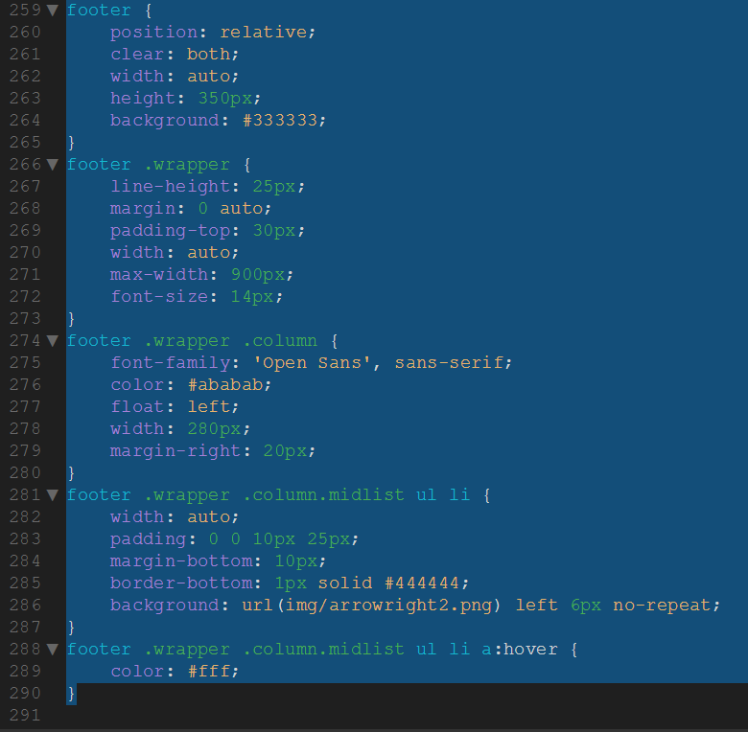

Figure 53 Styling the footer

In the right column we will set display to block for the span elements inside the list items. We want the text inside our span element to be displayed as block element in order to create a margin between the little image and our text. We float our image in order to position it next to the text. Since our span element containing the text is displayed as a block element we need to define a margin-left starting from the left border of our ulelement to create a space between the image and the text. For our images we will define a border and a transition for our border which will make sure the border color fades from one color to another on mouse-hover.

For our h4 headings inside the footer we set a font color which looks good on the dark background and define a bottom border just like we did for the previous headings. Add the following code to the bottom of the style.css file:-

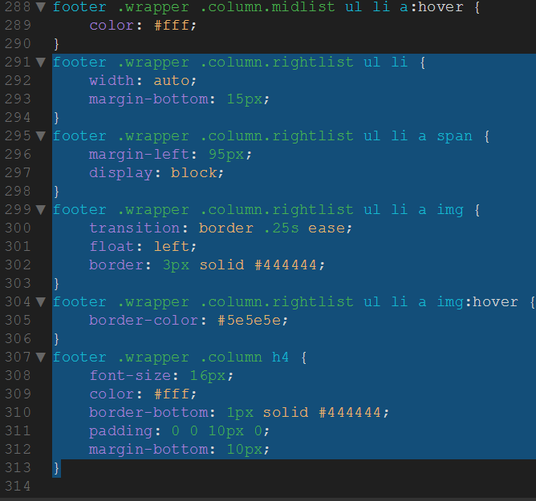

Figure 54 Styling the right column of the footer

Now that we have styled the footer let´s position our copyright notice at the very bottom of our footer. If you have a look at the HTML code you will see that we have a div with the ID “copyright” which we will position absolutely at the bottom of our footer and give it a slightly darker background color. The width of this divshould be similar to the width of our footer so we will set the width to 100%.

Inside our copyright section we have a div with the class “wrapper”. We do not have to set the width or the max-width for it as we have already defined a rule footer .wrapper which will apply. However we need to set the font color and font type, define a padding and set the position to relative to be able to position our social button links absolutely within the wrapper. The div with our social links should be positioned at the right corner and 25px from the top of our wrapper.

If you have a look at the HTML code you will see that our social buttons are simply made by wrapping an anchor around an image. As the links are positioned next to each other we need to make them float just like we did several times before. To achieve the hover effect we will simply set the opacity to about 30% and then to 70% or even more on mouse-hover. To make it fade smoothly from 30% to 70% opacity we define a transition. Add the following code to the bottom of the style.css file:-

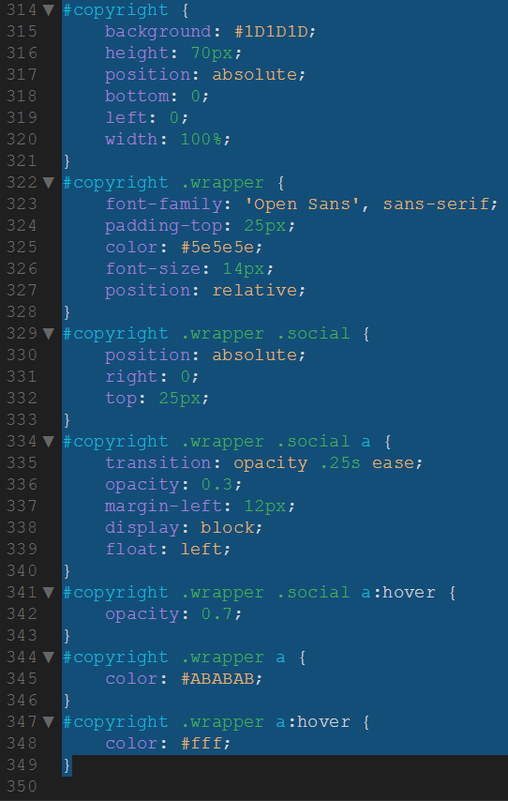

Figure 55 Styling the copyright section of the footer

The next section in our CSS file is called “MISC” and will contain different rules which you don´t know where to put them else. For our website we need to define two rules inside this section. In the HTML code you will find several br with a class “clear”. These are necessary to clear the floating which we used to horizontally position elements next to each other. Simply try not setting the class and you will see why we need it.

The second rule we still need to define is for our hidden headings. As mentioned in the previous part of this tutorial we need to define a heading for each section in our document to create a proper HTML5 outline. Since displaying these headings does not always make sense we will hide all elements which have the class “hidden” by using the CSS property clip. Add the following code to the bottom of your style.css file:-

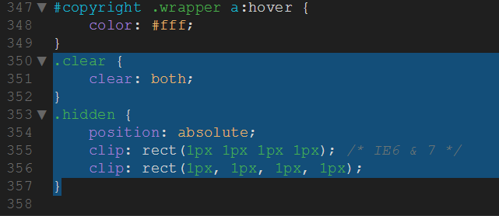

Figure 56 Finishing up the styling

For the most part, that’s the styling done. Preview the index.html file in Chorme and it should look like this:-

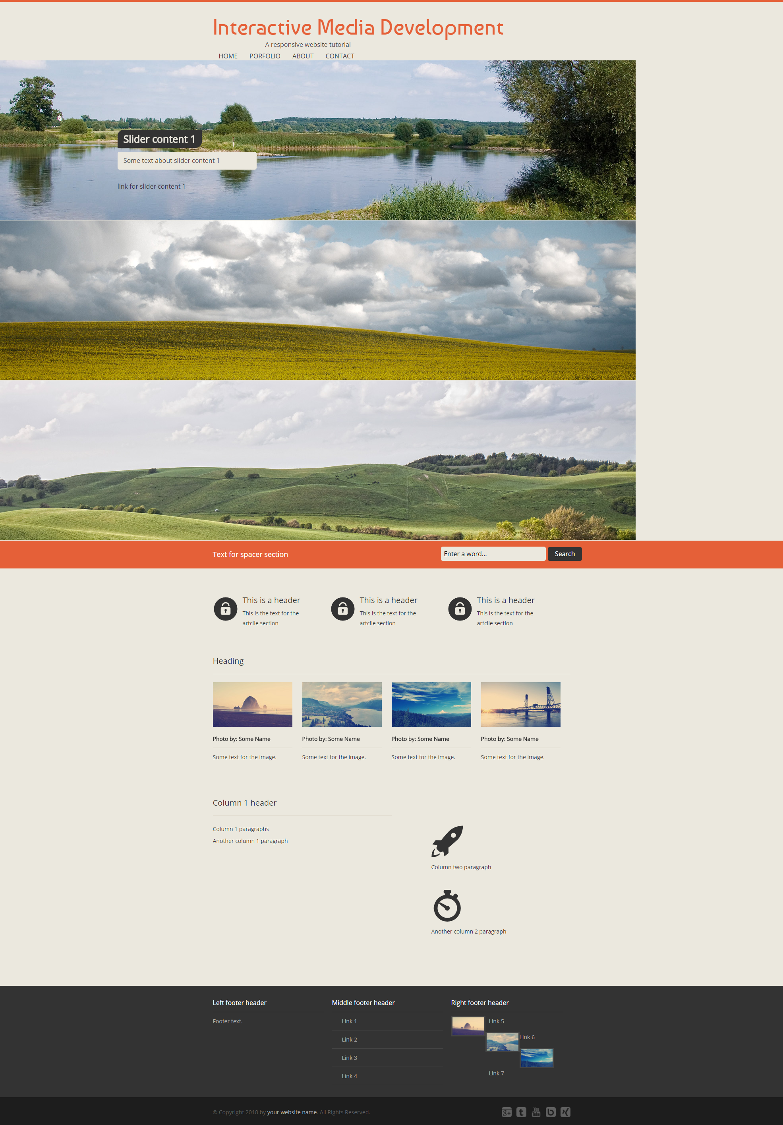

Figure 57 Preview of index.html with almost complete styling

Better, but not quite there. Now, confession time - I’ve made a mistake! See how the navbar looks odd? That’s because I’ve missed some code. Add the following code above your navbar section in the style.css file:-

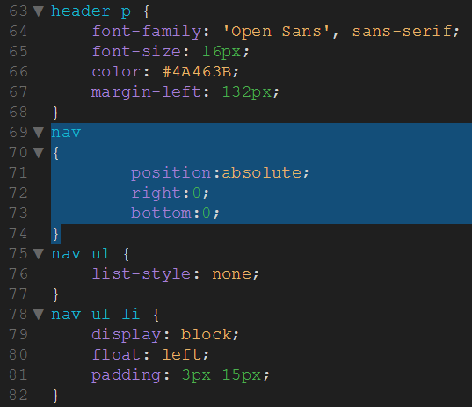

Figure 58 Correcting the styling of the navbar

Now let’s preview the index.html file in Chrome:-



Figure 59 Navbar styled correctly

That’s better! Oh, I’ve made another mistake. Look at the link in the section “link for slider content 1”. That’s supposed to be a button – but I’ve forgotten to style it! Add the following code below the slider section in your style.css file:-

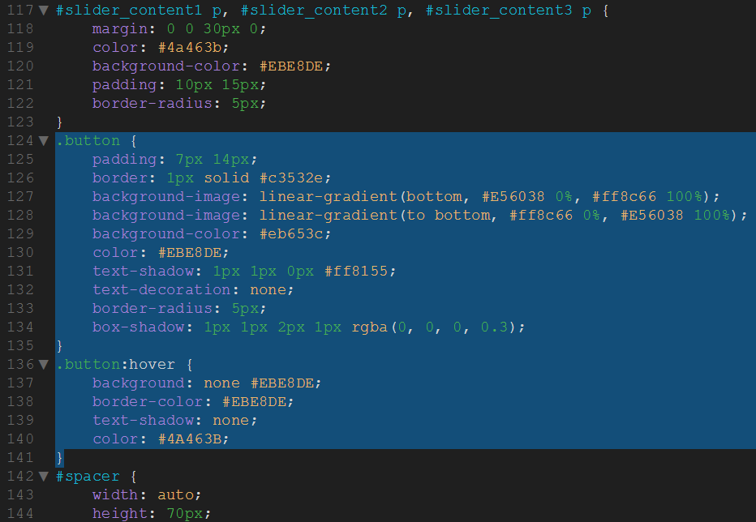

Figure 60 Styling the buttones

Perfect! Ah darn it, one more bug to fix. Look at the right hand side of the footer, see the links are staggered? Well, we can apply a quick fix for that to drop each link onto it’s own line. Add the following code in the index.html file:-

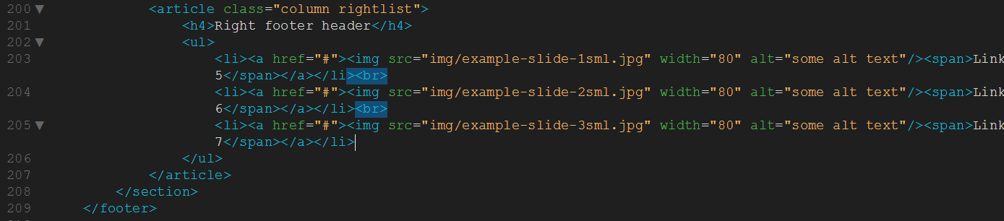

Figure 61 Setting each link on it's own line.

Now preview in Chrome:-

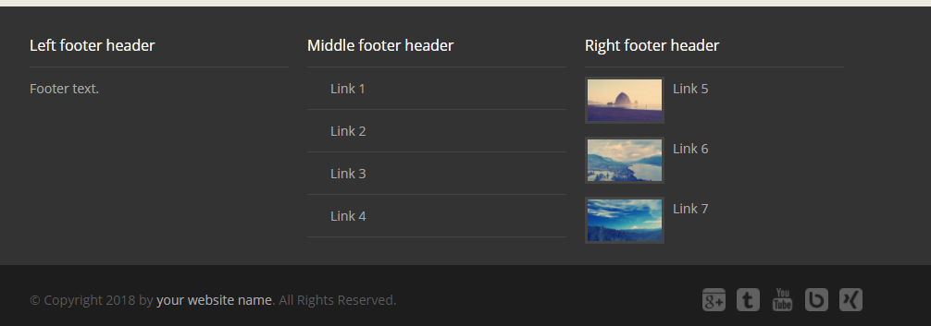

Figure 62 Corrected footer

Wahey! I think we’re good now. Ok, second confession time! I made those ‘mistakes’ on purpose to illustrate that in web development you should make small changes and test often. This gives you a chance to correct small mistakes before moving on to other sections. Talking of which…….

### Creating the styling – Making it responsive

We have finished styling our website and it should look just fairly ok. The only difference is that the website we just created is not yet entirely responsive. We have already set our width to auto and defined a max-width for our sections. However this will only change the width of our sections but the content inside these sections might be incorrectly positioned or overlapping. We will now use CSS Media Queries to specify certain rules for different browser window sizes. I will not cover the topic media queries in detail, if you want to know more about this topic check out the [web developer guide](https://developer.mozilla.org/en-US/docs/Web/Guide/CSS/Media_queries). In our website we will only use the max-width attribute for our media queries which defines the maximum width for the rule to take effect. So if you define a rule with a max-width of 765px then this rule will take effect as long as the viewport width is smaller than 765px or exactly 765px.

To make our website responsive we need to first of all think about what content is relevant and should be displayed on small displays like mobile phones or on tablets. When creating a website you need to already have in mind how it should look on a mobile phone at the very beginning of your development phase.

Start reducing the width of your browser window until you detect that some parts are incorrectly positioned or just don´t look good. In that case the easiest way to determine the current width of the website is to use your browser´s web development tool (right click > inspect in Chrome for example) to get the width of the body element. For that width we then need to define a media query to somehow change the layout of our website and make it look good again. However note that the width defined in our media queries can vary depending on the browser you are using. In Firefox the vertical scrollbar gets included in the viewport width which means that if you define a media query with a max-width of 1000px then in Firefox the media query rules will occur at about 985px. The 15px wide scrollbar is subtracted from the max-width. To read more about that topic check out [this blog post](http://iamkeir.com/post/26647025450/firefox-media-query-breakpoints-wtf). The solution for this problem in our case would be to just use a buffer and simply set our max-width a bit higher than necessary.

On our website the first thing you will notice when changing the width of your browser window to about 1215px is that the links in our slider is likely to overlap the spacer. How can we get rid of this problem? One way is to completely remove the link (set display to none) and put the link behind our paragraph as plain text. That way we will already save some space. To do so we still need to add some HTML code to our file. Add an anchor behind each of the paragraphs inside our slider content boxes and give it a class “responsive\_button”. Then add a rule into your CSS file to set display to none for all elements with a class “responsive\_button” inside a paragraph inside a slider content box. So first, add the following code in your index.html file:-

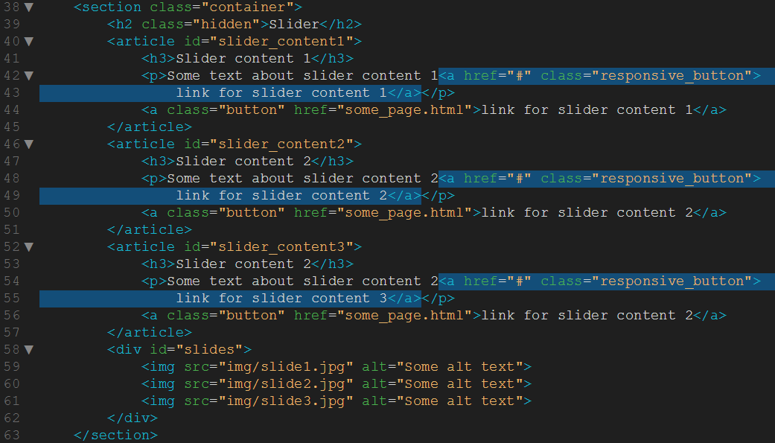

Figure 63 Adding responsive buttons

At the bottom of the style.css file, add the following code:-

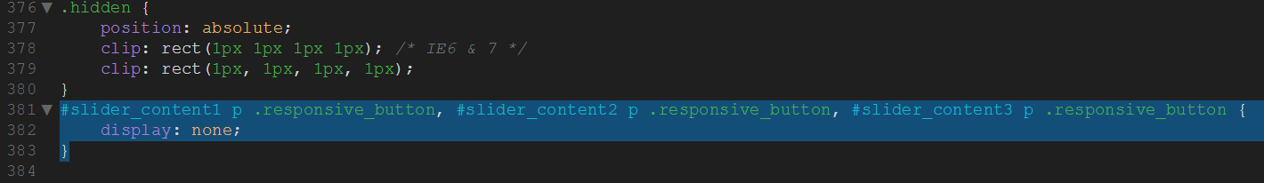

Figure 64 Hiding the responsive buttons as default

In our media query rule we now need to simply set display to inline to display it inline behind the paragraph text and define a font color.

However, there is still a problem since the text inside our paragraphs is still overlapping the orange spacer. What we could do here to solve this is to make the slider content wider. To do so we set its width to auto to make it adapt to the parent element and give it a margin-right to create a free space between the slider content boxes and the right edge of our slider images. Also we want the font size to be smaller which will save some space and looks a bit lighter. Add the following code at the bottom of your style.css file:-

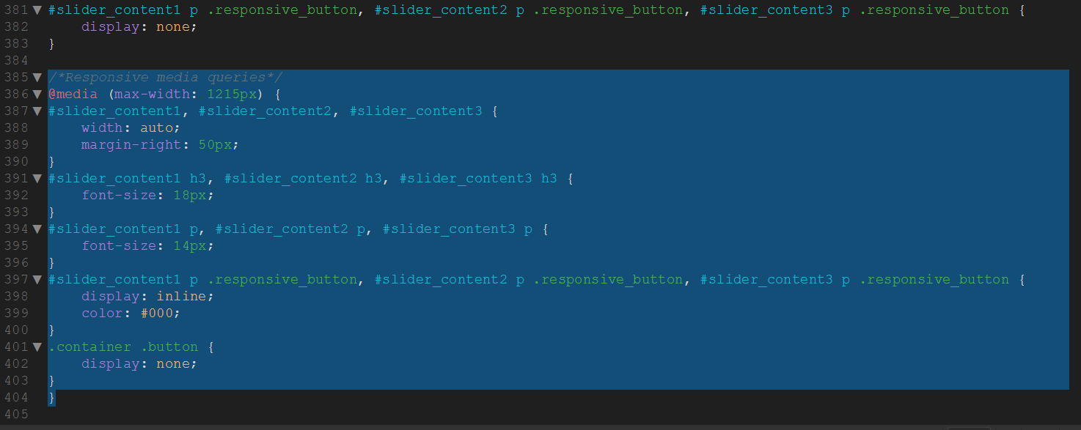

Figure 65 Media queries to stop overlaps

When reducing the width even more you will notice that when we get below the max-width of 900px which we have set for our website the floated articles will not be next to each other anymore. To get rid of the Firefox scrollbar problem I told you about we will add 15px and define a media query for a max-width of 915px. Since the articles don´t fit next to each other anymore we will position them one below the other horizontally centered. To do so we need to remove the floating and set margin-right and margin-left to auto. Also we change the width to 60% to make it change its width depending on the website´s width.

We also have the problem that below 900px the orange spacer with the search form will not fit anymore. To solve this let´s change the font size of the spacer and the input field, reposition the paragraph with the question text inside and change the size of our input field by adjusting the padding values.

Another problem occurs with the section “four\_columns”. Below 900px some of the articles with the class “img-item” might wrap and overlap the other articles. To solve this problem we will set a specific width to our section so that two articles wrap to the next line. Then we define a margin-top for the two wrapped articles to create a space between the two lines. To address only the third and fourth article (which are the ones in the second row) we will use the CSS3 feature nth-of-type. Note though that this will not work in IE8 or below. If you want to assure full browser support you could give a specific class to the third and fourth article instead.

For the section text\_columns we also need to reposition the articles. To do so let´s remove the floating and change the width of the two columns by overwriting the value for max-width. To center the articles within the section we will set margin-left and margin-right to auto just as we did several times before. We also don´t want the two articles inside the second column (the ones with the rocket and the clock icons) to be floated right anymore and need to readjust the margin to make it look good.

The last section we need to adjust at 900px is the footer. To make it fit the smaller width of our website we will reduce the font size and the width of the three columns. Add the following media query to the bottom of the style.css file:-

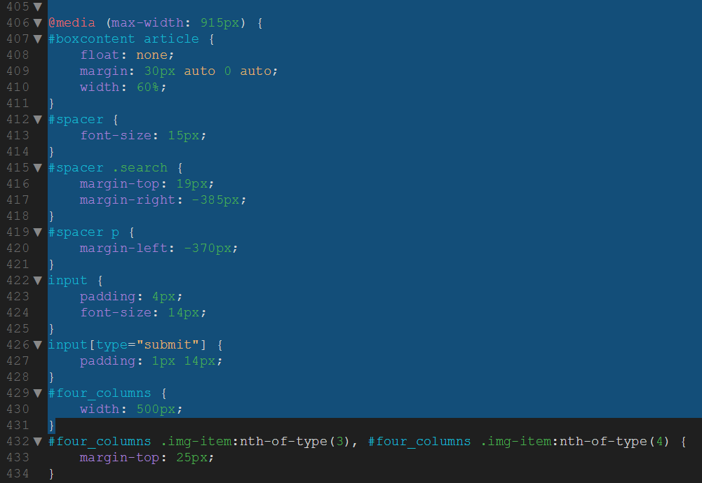

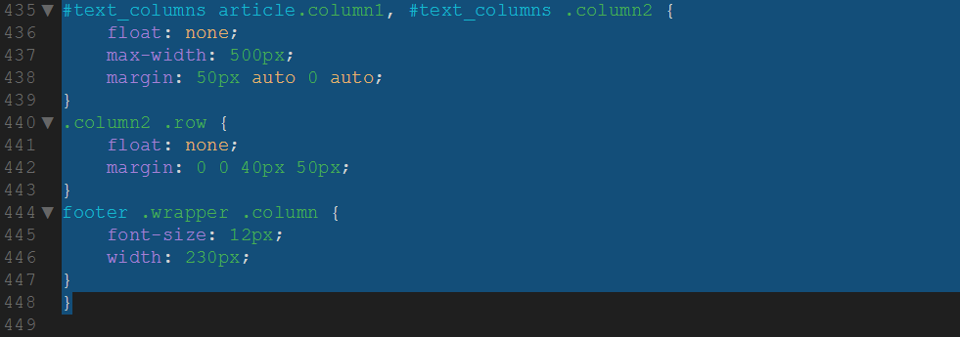

Figure 66 Media query to make the four columns section responsive

When reducing the width of your browser even more you will notice that at some point the slideshow is just too small and does not look good anymore. To remove it we will set the top value to a high negative value to make it disappear. We can not use display to remove it because the slideshow will not appear again if it has been removed. As the slideshow has disappeared the orange spacer will start overlapping our navigation so we need to define a fixed height for our header. We can also reposition our navigation because now that everything has been centered it might look better to center the navigation as well. To center it we first need to overwrite our top and bottom values by setting them to auto. Then we set the left attribute to 50% and define a negative margin corresponding to half of the navigation´s width.

We also got some issues concerning the spacer. The search form and the paragraph do not fit next to each other anymore so we need to position them below each other. We define a fixed height for the spacer and setmargin-right and margin-left to auto to center it. To get rid of any margin and the left value we will set the position to static. By defining a padding we create some free space above and below the paragraph. Just as we did for the paragraph we will do the same for our search form.

Because our footer does not fit anymore we will position the three columns of our footer below each other. To achieve this we first need to set the height to auto as it has been set to 350px before. Then we set a fixed width to the wrapper inside the footer and center it. The three columns inside the wrapper should not float anymore as they should be positioned below each other. We also set the width to auto in order to make it fill out the whole width of the wrapper. Since there is not a lot of space in the footer we will completely remove the social links. Add the following media query to the bottom of your style.css file:-

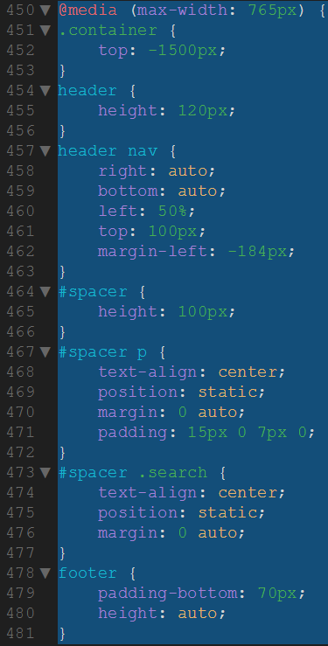

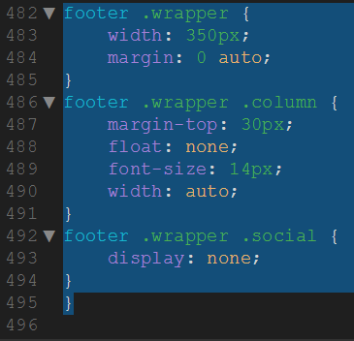

Figure 67 Making the footer responsive with a media query

If you look at the website again and reduce your browser´s width you will see that the website will now respond to the changing width and look good at any screen size. Obviously you can always do more to make the website look even better on different screen sizes. Just play around a bit with the values and add rules for any element you want to change at a specific screen size.

# Part 3

In this third part of my tutorial we will be building the JavaScript and jQuery and do the necessary steps for interactive web design to create this beautiful HTML5 responsive website. Be sure to have worked through the first and second parts of this tutorial where we have built the basic HTML structure, included all necessary scripts and styled the page accordingly.

## Creating interactivity – JavaScript and jQuery

JavaScript and jQuery can be used to improve the interactivity of a website.

Alongside HTML and CSS, JavaScript is one of the three core technologies of World Wide Web content engineering. It is used to make webpages interactive and provide online programs, including video games. The majority of websites employ it, and all modern web browsers support it without the need for plug-ins by means of a built-in JavaScript engine.

jQuery is a lightweight, "write less, do more", JavaScript library.

The purpose of jQuery is to make it much easier to use JavaScript on your website.

jQuery takes a lot of common tasks that require many lines of JavaScript code to accomplish, and wraps them into methods that you can call with a single line of code.

jQuery also simplifies a lot of the complicated things from JavaScript, like AJAX calls and DOM manipulation.

The jQuery library contains the following features:

* HTML/DOM manipulation
* CSS manipulation
* HTML event methods
* Effects and animations
* AJAX
* Utilities

### Creating the JavaScript – Coding the slider content

Now that we have finished our styling we will create the JavaScript code for our slider content boxes to appear and disappear when the slider image changes. For the Slider to work we will add the JavaScript code just like in the example file of the SlidesJS plugin and make a few adjustments. For some reason we need to define a height in the JavaScript function which is much smaller than the actual slider images. I am not yet sure why this is but simply choose a height which makes the slider look good, in our case at about 235px.

In order for our slider content boxes to appear and disappear whenever a slider image is changing we need to add two callback functions. The first callback will fire when a slide starts to change to another, the second one whenever a slide has entered and is not moving anymore. In the start callback we will add a rule to fade out all the slider content boxes because as a slide changes we don´t want any box to be visible. In the complete callback we will fade in the slider content box corresponding to the current image. So say the second image is shown then “slider\_content2” will fade in. To achieve this we can add a variable into our complete function which will always give us the current slide number. Add the following code just below the last script tag in the head section of your index.html file:-

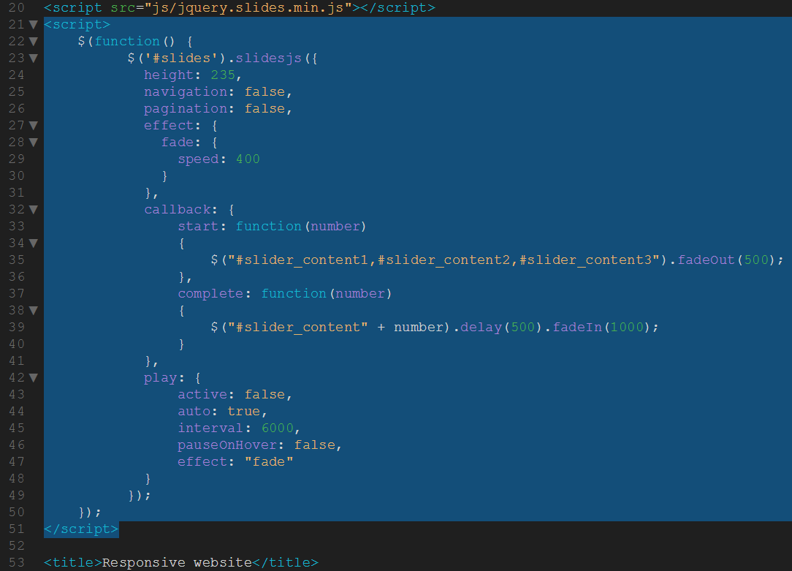

Figure 68 Script for controlling the slider

Also, I’ve just realized I forgot one part of my css that controls how the slides show when transitioning (prevents a black space). Add the following code in your style.css file:-

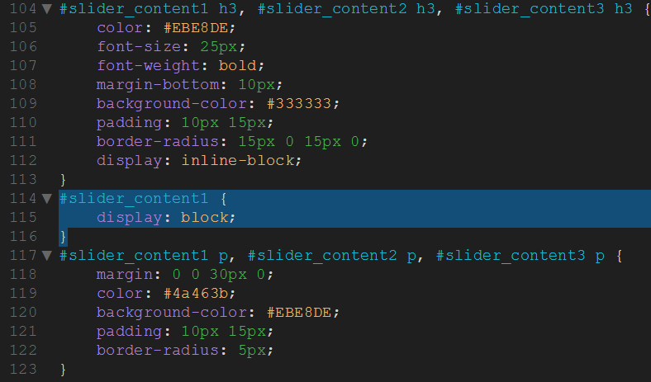

Figure 69 Style addition for slide content

Now preview the index.html file in Chrome. Magic eh? Just those 28 lines of jQuery (we knoe it’s jQuery because the functions are prefixed with a $ symbol, which is code shorthand for jQuery) have activated the slide and made it work. Notice how all the styling works now as well? Wonderful!



Figure 70 It's so purty!

### Creating the JavaScript – Coding the mobile menu

Let´s start creating a mobile navigation which toggles down when clicking on the symbol in the top left corner. First of all we need to add the HTML code for the mobile navigation. We could of course simply use the existing navigation and adapt it on mobile screens but in our case we add a separate menu because we would like to have different menu items on mobile than on desktop screens.

To start let´s add a div with the ID mobileMenu. Add an unordered list with all the menu items as li elements inside. That´s it for the menu, now let´s add the HTML code for the symbol in the top left corner (three bars above each other). The bars are made by adding three span elements inside a div element and positioning them one above the other. Put the code above the h1  element in the header section . The whole HTML code should look like this:-

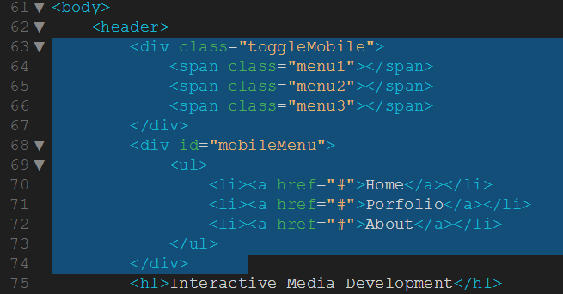

Figure 71 Mobile menu

Now let´s move on to the jQuery part of our mobile navigation. When the page is loaded we would like to first of all hide the mobile menu by default (since it should only be visible when clicking on the symbol). When clicking on .toggleMobile we would like the mobileMenu to slide down or up depending on whether it is already open or not (this is done by using the jQuery slideToggle function). Also we would like to animate the .toggleMobile symbol just like in the preview. We are going to do that using CSS3 transitions and therefore all we have to do is add a class active to our symbol. To make sure that when somebody resizes their browser window to a width higher than 765px the mobile navigation should not be displayed we also add a resize event which fires when the user changes the browser width. Within that resize event we test whether the current browser width is larger than 765px and if so we hide the mobile menu and remove the active class from our .toggleMobile. Add the following code below the last script tag in the head  section of your index.html file:-

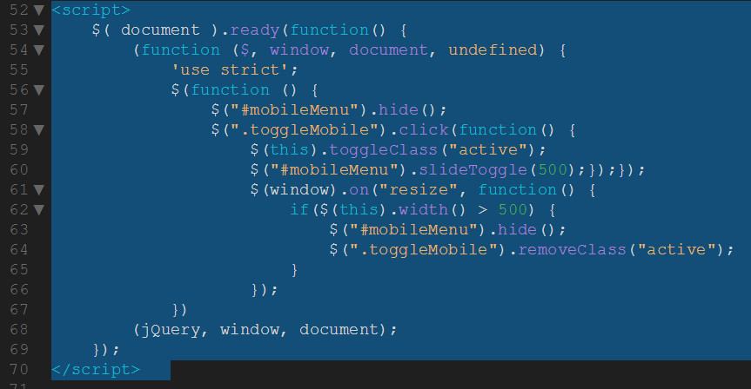

Figure 72 Adding the jQuery to control the mobile menu

The $( document ).ready(function() { } ); bit tells the browser not to run this code until the whole page has finished loading. This stop conflicts with other scripts and unexpected behavior.

Now let´s move on to the CSS code for our mobile navigation. We want the navigation to be positioned fixed at the very top of our page. The menu should be as wide as the browser window (100%) and not be displayed by default. Just above the figcaption element in the style.css file, add the following code:-

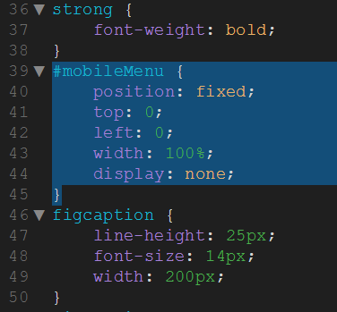

Figure 73 Styling the mobile menu

The list elements inside our navigation (which are the menu items) should be displayed as block elements. You can style them however you would like to, in our case we use an orange background color, a white font, some padding and letter spacing as well as a slight border. Also we want the text to be centered and uppercase. Add the following code to the style.css file, just below the previous mobile element:-

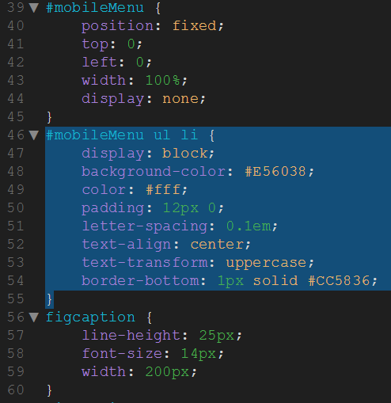

Figure 74 Styling the list style of the mobile menu

The mobile toggle switch in the top left corner should not be displayed by default since we will only make it visible on screen sizes smaller than 765px using media queries. Add the following code to the stylle.css file:-

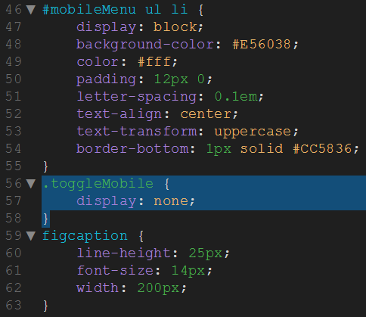

Figure 75 Setting the mobile menu toggle to not display by default

Now let´s move on to our media queries section within the CSS file and add the code for screen sizes below 765px. We want our mobile menu to be visible on small screens and to be above any other elements, so we define a z-index which should be high enough in order for the menu to actually be positioned above the other content. Add the following code in the 765px media query section of the style.css file:-

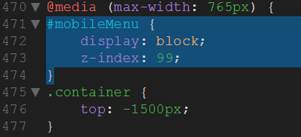

Figure 76 Displaying the mobile menu if screen =< 765px

Next let´s position the toggle switch fixed at the top left corner, give it a width of 40px and a height of 36px and make the z-index higher than the one for the mobile menu (since we would like the switch to be above the menu when it is open). Add the following code just below the #mobilemenu element in the style.css file:-

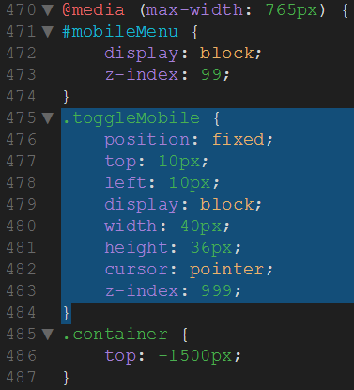

Figure 77 Positioning the mobile menu

Now let´s move on to the cool part, we would like the three bars of our switch to be positioned absolutely within the .toggleMobile div. Also they should be 40px wide and 8px high, have a background color and a transition effect with a custom easing bezier curve. As mentioned earlier in this tutorial the third argument of the transition attribute describes the way an animation should be played. You can use [this tool](http://matthewlein.com/ceaser/) to create your own bezier curves or use an existing like ease or linear. Also we want the transition to address all possible properties which can be animated and the duration of the transition should be 0.35 seconds. Add the following code in the style.css file:-

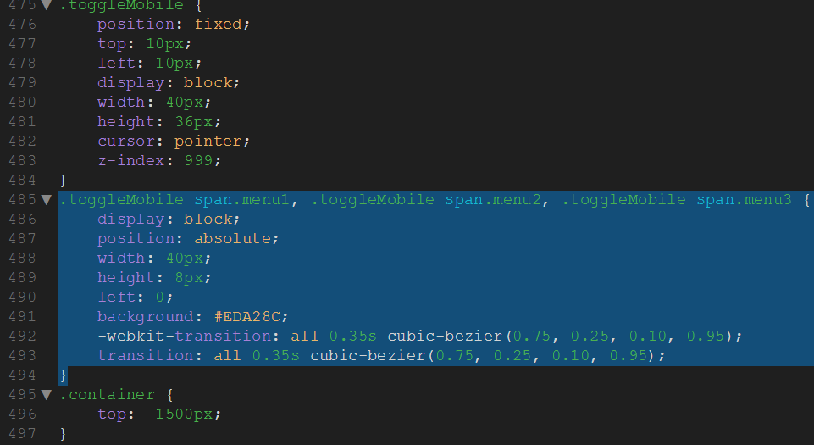

Figure 78 Creating the bars for the mobile menu

Since we would like the bars to be one above the other we will now change the top value for each of the bars. Add the following code to the style.css file:-

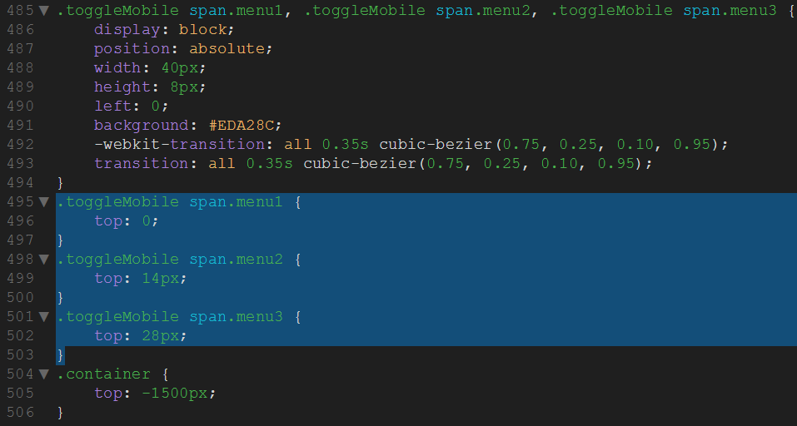

Figure 79 Stacking the bars of the mobile menu

Now we need to define the active class for our switch. When the switch has been clicked and the menu is open the lowest of the three bars should be hidden, the others should be positioned one above the other and then be contrary rotated. Add the following code to the style.css file:-

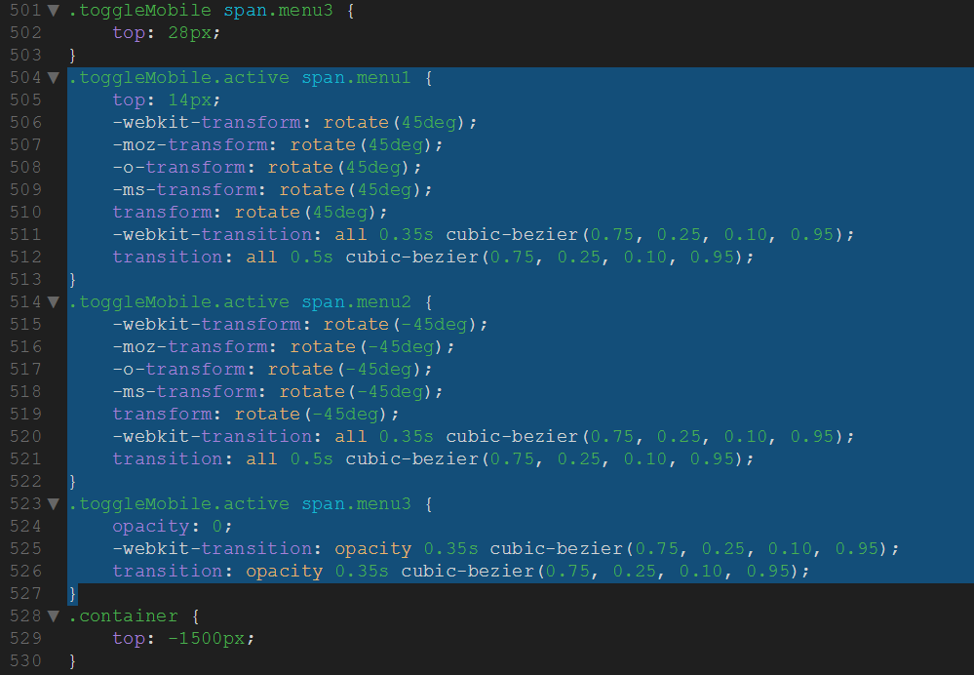

Figure 80 Defining the active class

Ok, now is probably a good time to test our code (remember, change little and test often. Preview the index.html code in Chrome. Reduce the browser window to < 765px and try clicking the menu icon:-

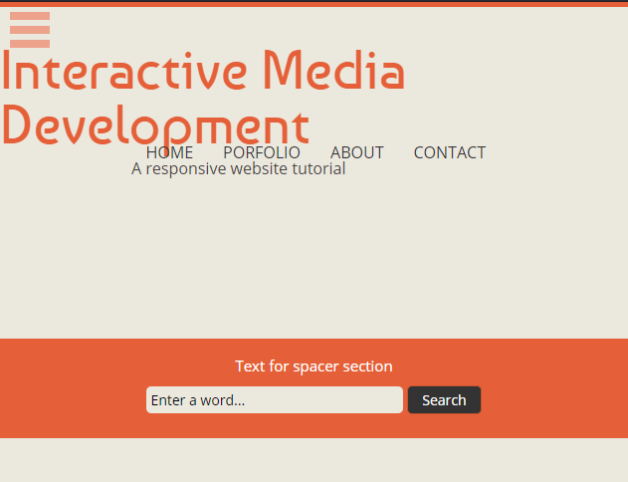

Figure 81 Mobile menu

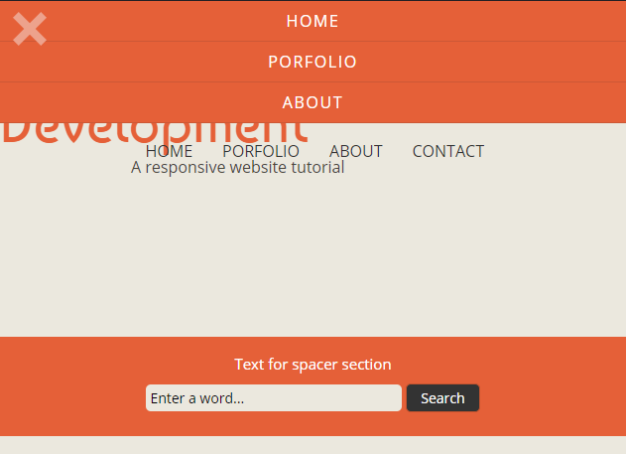

Figure 82 Mobile menu active

Almost there! I’d like to hide the desktop navigation menu when the mobile menu is visible and we have a bit of a weird blank space where the slider used to be. I’d also like to center the header content, so let’s do that now. In the same 765px media query, add the following code:-

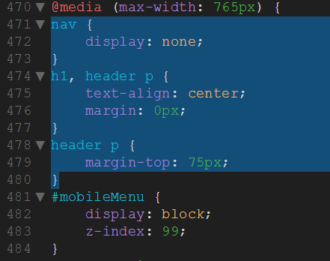

Figure 83 Tidying up the mobile menu

Now save and preview the index.html file again:-

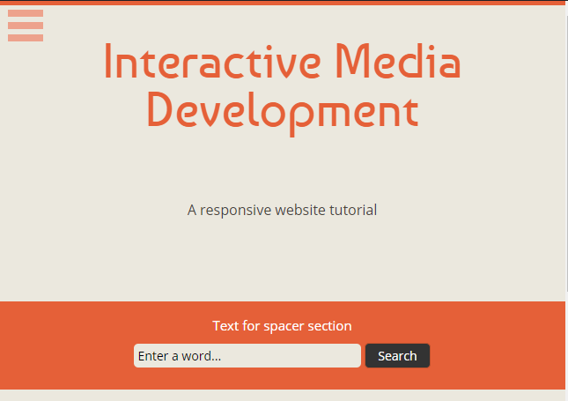

Figure 84 Mobile menu

Absolutely perfect! You now have a fully functioning responsive website. All that’s left for you to do is populate the website with working links and create more pages for your visitors to visit. TIP! Rather than creating each page from scratch, copy the index.html page and rename it, i.e. contact.html. In fact, why don’t we do just that and create a working contact form? Onto part 5!

# Part 5

## Adding a contact form

A common feature of many websites is a contact form. Standard contact forms work just fine, but you can make them nicer by using AJAX to submit the form data in the background.

In this section, you’re going to learn how to create a website contact form that submits the form data using AJAX. We’ll be using jQuery to help simplify the JavaScript code and a simple PHP mailer script to handle sending the form data via email.

Let’s get started.

### Building the HTML Form

Responsive website folder, copy the index.html file and rename it to contact.html. When you refresh your local files list, you should see it listed.

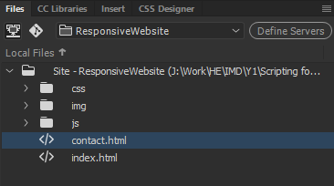

Figure 85 Creating the contact page

Before we open that page, we need to point the menu links on index.html to contact.html. Edit the following code in your index.html file:-

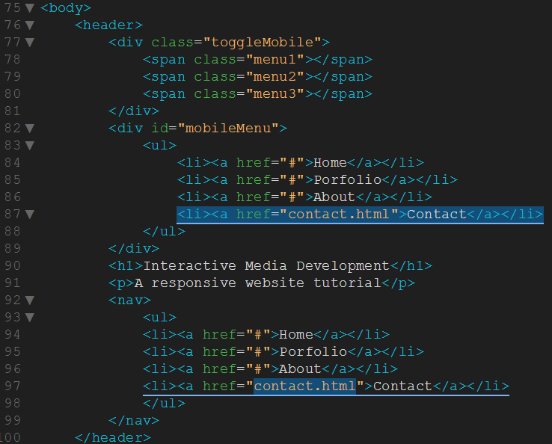

Figure 86 Pointing the links to contact.html

In the files window, double click contact.html. Now, you’ll note it looks pretty much the same as the index.html file. Well, it should really, we just copied it! But now we need to make it unique, and again we’re going to start with the menu items. Edit the following code in the contact.html file;-

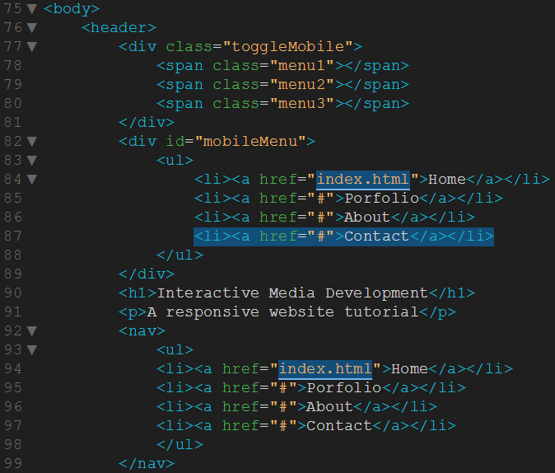

Figure 87 Editing the menu links on the contact.html page

So what we’ve done there is point back to the index.html page when the Home link is pressed. You’ll have to do this every time you create new pages for your website. It’s worth testing all the links on your site as they are easy to miss.

We’ll start building our contact form now, but we need to decide where we are going to put it. For the purpose of this tutorial, we’re going to leave the slider, but replace the other content. So, delete the boxcontent, four\_columns and text\_columns sections from the contact.html page, so the code looks like this:-

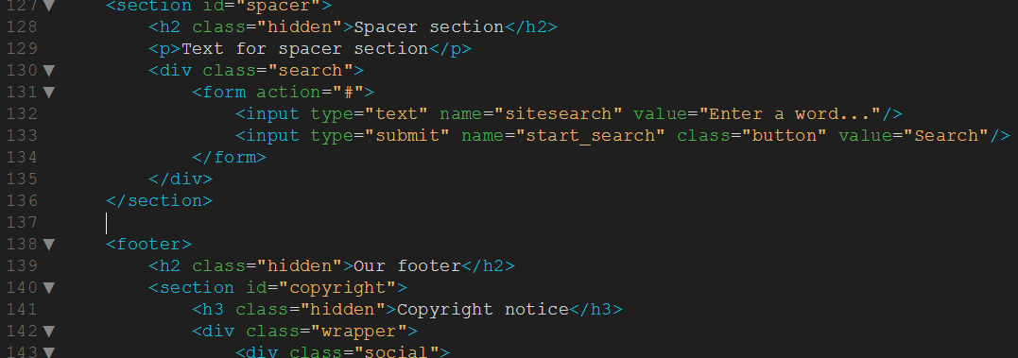

Figure 88 content deleted between the spacer and footer sections

Now we’re going to add back in the boxcontent section but with less information, like this:-

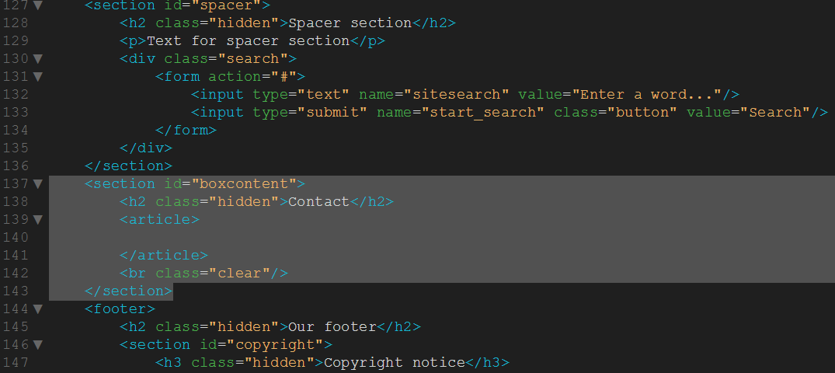

Figure 89 Creating an area for the contact form

Preview the contact.html file in Chrome and it should look like this:-



Figure 90 Space for the contact form

Right, now we’ve got somewhere to put our contact form, let’s get building. We’ll Give your form element the ID of ajax-contact, set the method attribute to post, and the action attribute to mailer.php. Add the following code in the boxcontent section of contact.html:-

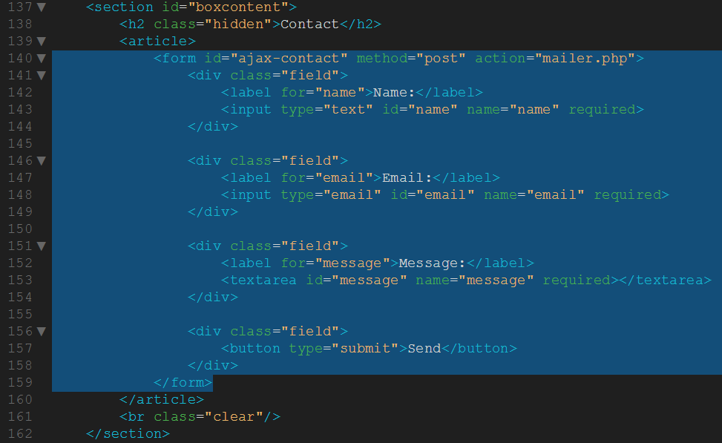

Figure 91 Adding the form

Now we want to style the form. As we’ve already covered CSS in depth previously, I’m not going to explain it in detail. In fact, you can just have the code as I’m feeling SUPER nice! In your style.css, create a gap between the strong and the mobilemenu elements, like this:-

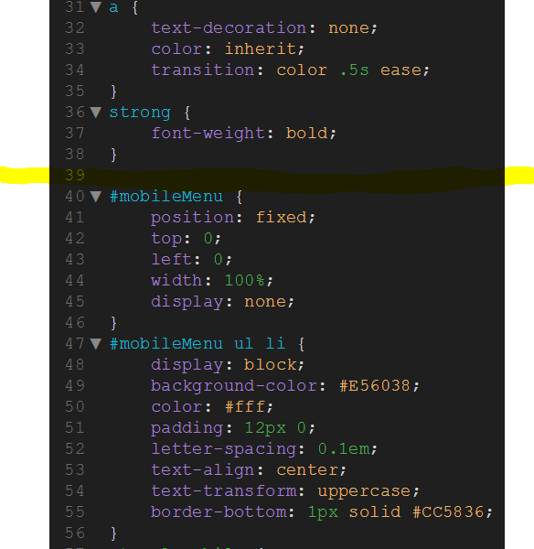

Figure 92 Put form CSS here

Now copy the code below and paste it into that gap.

#boxcontent .field {

margin: 1em 0;

}

#boxcontent label {

display: block;

margin-top: 2em;

margin-bottom: 0.5em;

color: #999999;

}

#boxcontent input {

width: 100%;

padding: 0.5em 0.5em;

font-size: 1.2em;

border-radius: 3px;

border: 1px solid #D9D9D9;

background: lightgray;

}

#boxcontent textarea {

width: 100%;

height: 200px;

padding: 0.5em 0.5em;

font-size: 1.2em;

border-radius: 3px;

border: 1px solid #D9D9D9;

background: lightgray;

}

#boxcontent button {

display: inline-block;

border-radius: 3px;

border: none;

font-size: 0.9rem;

padding: 0.5rem 0.8em;

background: #69c773;

border-bottom: 1px solid #498b50;

color: white;

-webkit-font-smoothing: antialiased;

font-weight: bold;

margin: 0;

width: 100%;

text-align: center;

}

#boxcontent button:hover, button:focus {

opacity: 0.75;

cursor: pointer;

}

#boxcontent button:active {

opacity: 1;

box-shadow: 0 -3px 10px rgba(0, 0, 0, 0.1) inset;

}

Ok, now save and preview the contact.html form in Chrome. It should look like this:-

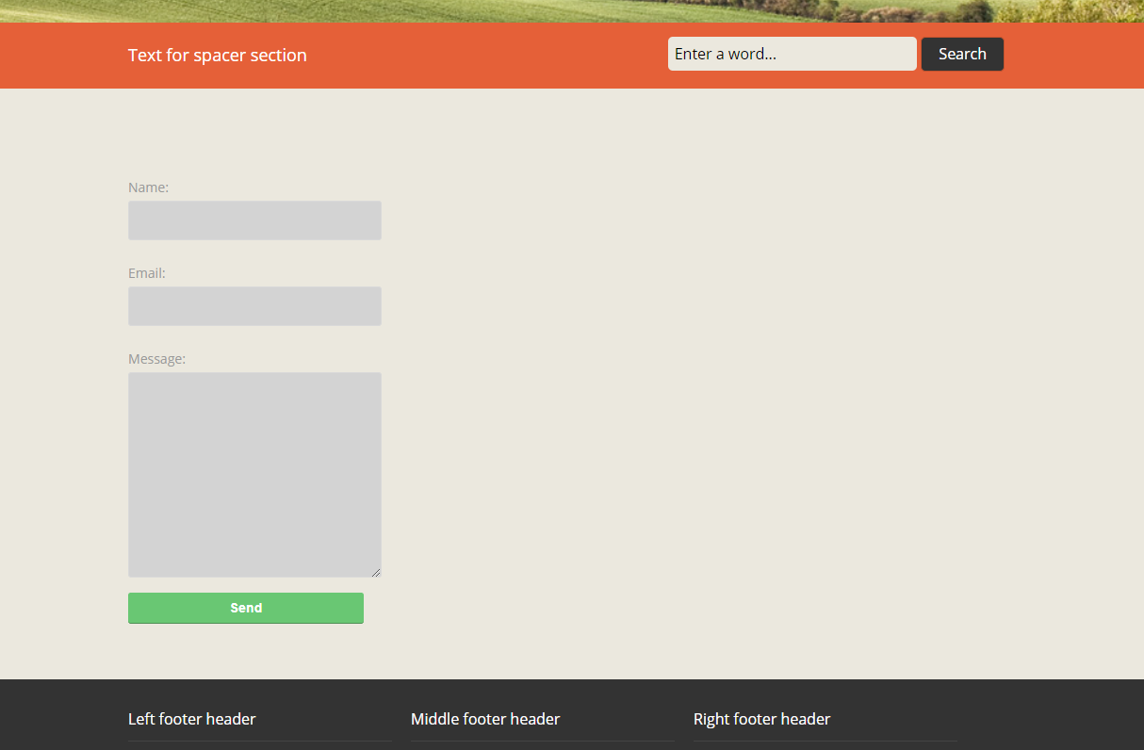

Figure 93 Contact form

That’s better. We might want to make it wider and center it later, but this will do for now.

Here we have set up a simple form that has fields to collect the user’s name, email address, and message. Notice that each of the form fields has a required attribute. In browsers that support HTML5 form validation, this will prevent the form from being submitted until all the fields have been completed.

Next we need to create a div element that will be used to display success and error messages to the user. Create this element above the form in your HTML markup and give it the ID form-messages. Add the code as show below to the contact.html file:-

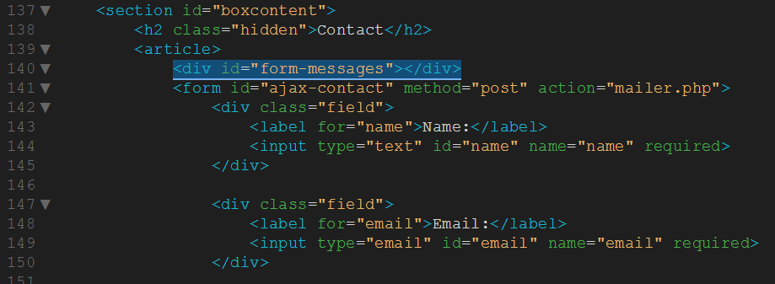

Figure 94 Div to display form messages

That’s the HTML5 and CSS3 complete for the form.

### Submitting the Form Using AJAX

Now we’re going to create the jQuery and AJAX that controls the submission of the form. In the contact.html file, enter the following code at the end of the existing $(document).ready function, like this:-

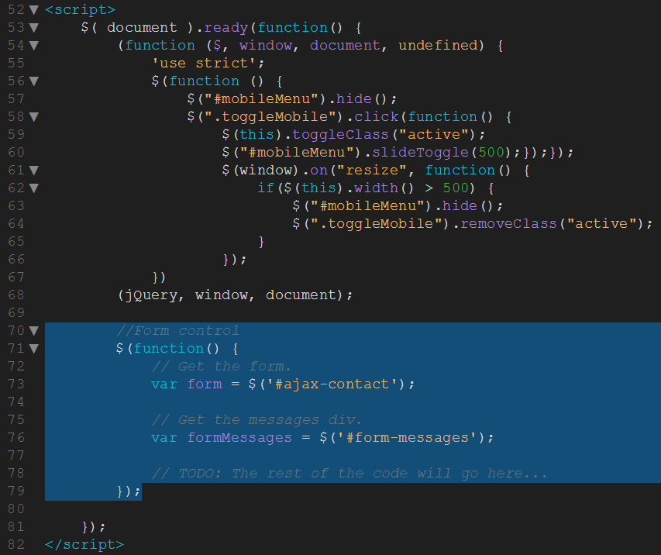

Figure 95 jQuery form control

Here you’ve created two new variables, form and formMessages, that reference the corresponding elements in your HTML markup.

Next you need to create an event listener that will intercept submit events on the form. You can do this using the jQuery submit method. Add the following code to the contact.html file:-

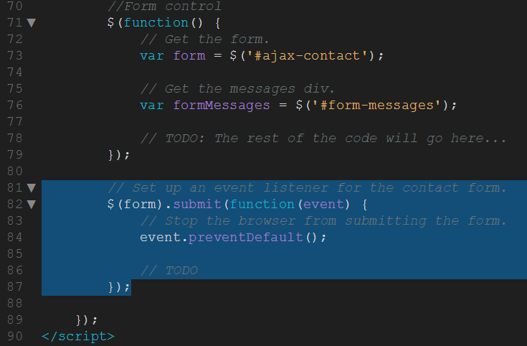

Figure 96 Form submit event listener

Here we’ve passed a function to the submit method that will be executed when the user submits the contact form. We’ve also told the browser not to submit the form as it would normally by calling the preventDefault method on the event.

Next we need to serialize the form data. This will convert the data the user has entered into the form into a key/value string that can be sent with the AJAX request. Use the jQuery serialize method to serialize the form data and then store the result in a variable called formData. Add the following code:-

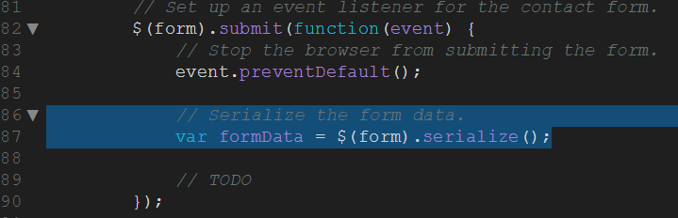

Figure 97 Serialize data

Now we’re ready to write the code that’s responsible for sending the form data to the server and processing the response. Add the following code:-

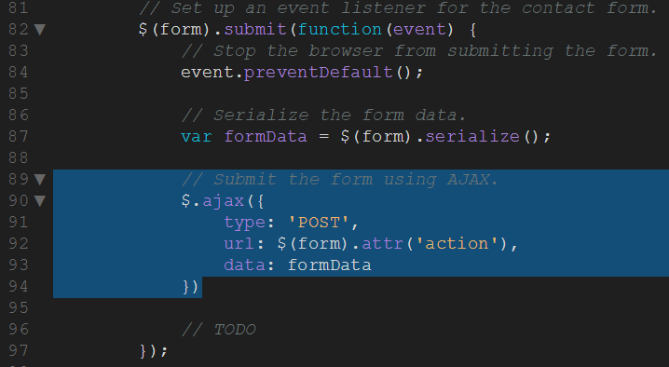

Figure 98 Send data to the server with AJAX

Here we’re using jQuery’s ajax method to create a new AJAX request. We’ve passed an object to the ajax method that contains a number of properties used to configure the request. The type property specifies the HTTP method that will be used for the request, in our case POST. The url property is the location of the script that the form data will be sent to. We’ve populated this property by fetching the action attribute from the form (i.e. the value of mailer.php). Finally, the data property has been populated using the formData variable that we created earlier.

Next we need to handle a successful response from the server. Add the following code directly after the closing bracket of the ajax call. Note that I’ve deliberatly left out the semi-colon:-

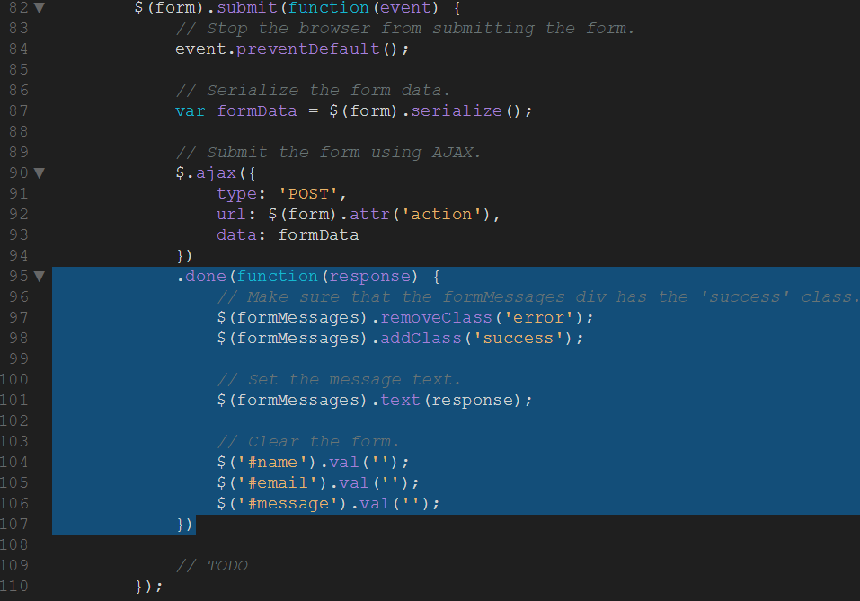

Figure 99 'Success' response handling

This done method will be called if the request completes successfully. Here we first make sure that the formMessages element has the success class and then set the text content of this element using the data returned by the mailer script. To finish, we clear out the values from each of the form fields.

The last bit of JavaScript we need to write handles what should happen if an error occurs. Add the following code:-

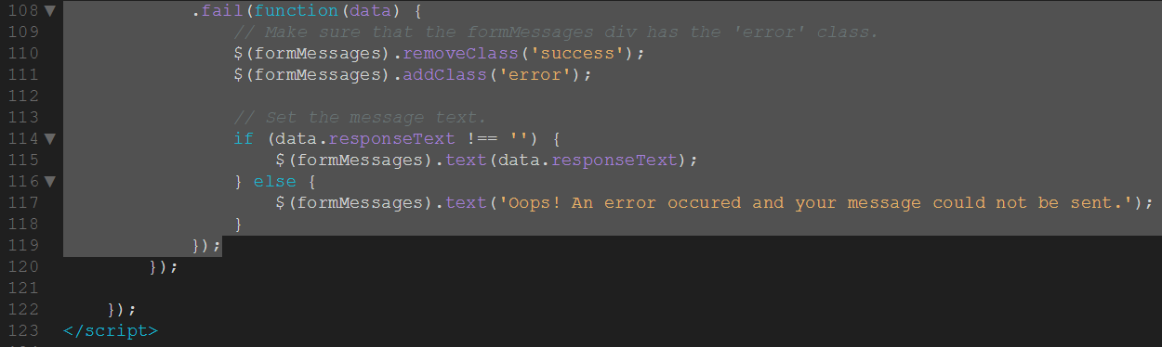

Figure 100 'Fail' response handling

This fail method is called if the mailer script returns an error. Here we first make sure that the formMessages element has the error class. We then check to see if the AJAX request returned any responseText. If it did, we use this text to set the content for the formMessages element; otherwise use a generic error message.

That completes the HTML and JavaScript code that’s needed to build an AJAX contact form. In the next section we’re going to learn about the mailer script that is responsible for processing the form data and sending out an email.

### Creating the PHP Mailer Script

Now it’s time to write the PHP mailer script that will process the form data. This simple script is responsible for checking that the form data is valid and then sending out the email. If an error occurs, the mailer script will respond with an appropriate status code so that the JavaScript within the fail callback you wrote earlier will be executed.

From this point on, it’s important to note that as PHP is server side script, we need to upload our site to a web host or use XAMPP in order to test the contact form submission. If you need help uploading to your web host, your hosting providers online support pages are a great place to start if you’re having difficulties. Appendix A contains instructions to upload to the college server and Appendix B instructions on using XAMPP.

In the files panel, create a new file called mailer.php.

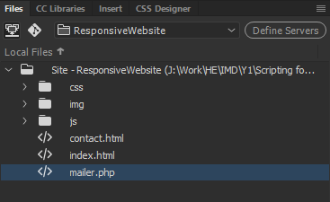

Figure 101 Creating mailer.php file

Double click the mailer.php file, delete all the default code and add the following:-

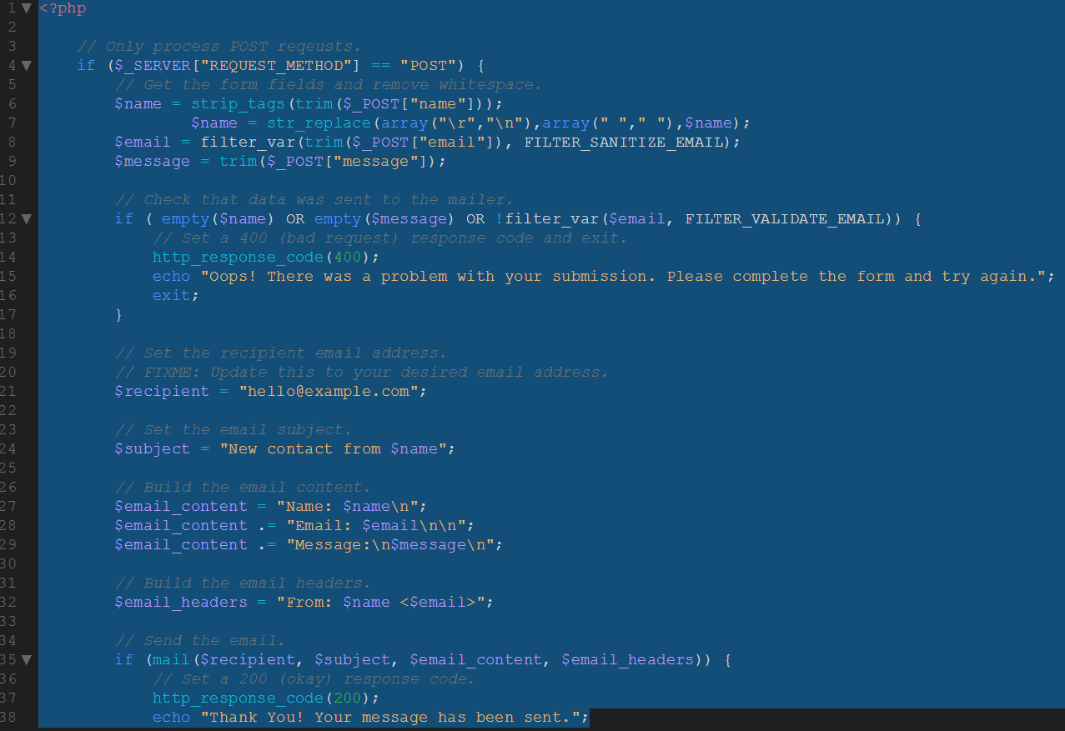

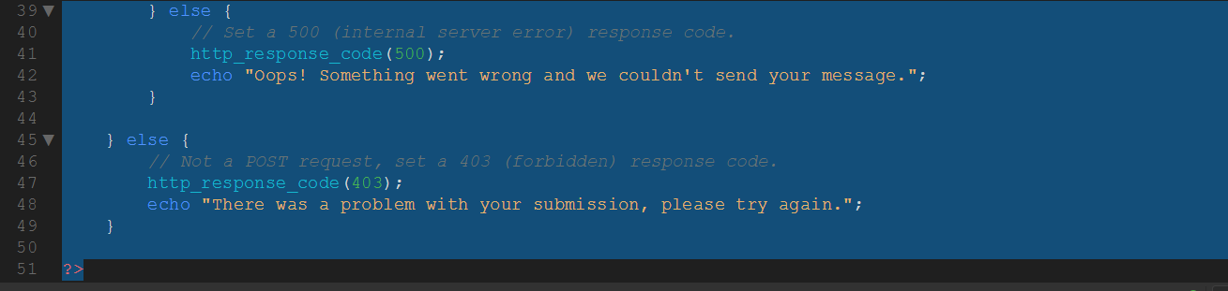

Figure 102 php mailer code

This script starts by checking that the request was sent using the POST method. If it wasn’t, the script will return a 403 (forbidden) HTTP status code and an error message.

Once you’ve established that the correct HTTP method has been used you then extract the form data into three variables $name, $email, and $message. You also use the PHP trim method here to cut out any unwanted whitespace.

Next you will check to make sure that none of these variables is blank. If one or more is blank, set the response code to 400 (bad request) and return an error message to the browser.

Now that you’ve determined the data is clean, you prepare the email, first by creating a variable with the email recipient. You then create variables for the subject, email content, and finally the email headers.

**Note:** Setting the email headers is optional. Doing so will make the email appear as though it was sent by the person that filled out the form. However, it’s important to note that manipulating the headers like this can also cause the email to be marked as spam by some email clients.

Next you will attempt to send the email using the PHP mail function. If this is successful, you will return a success message. If it’s not, you need to set the response code to 500 (internal server error) and return an error message.

**Note:** The standard PHP mail function will do just fine for the purposes of this blog post, but there are more robust ways of sending email using PHP. If you’re interested in learning more, I recommend that you check out the Build a Simple PHP Application project on Treehouse.

Upload ALL your website files to your webhost, navigate to the contact.html page and test your form. It should now work, like this:-

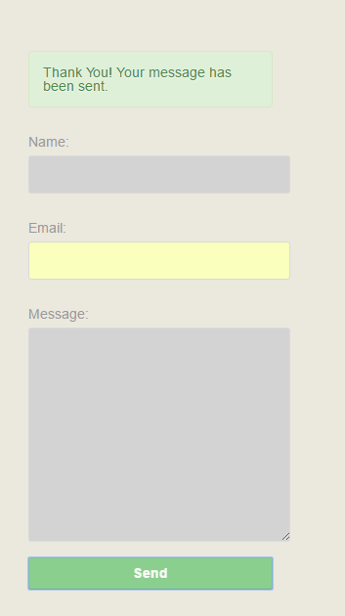

Figure 103 Working contact form

And that’s it, you’ve now added an AJAX contact form to your fully responsive, jQuery enable website.

Now, create a copy of your responsive website folder and have a play – turn it into your own site my amending the fonts, colours and images. Add more pages and content.

# Appendices

## Appendix A



## Appendix B

## 